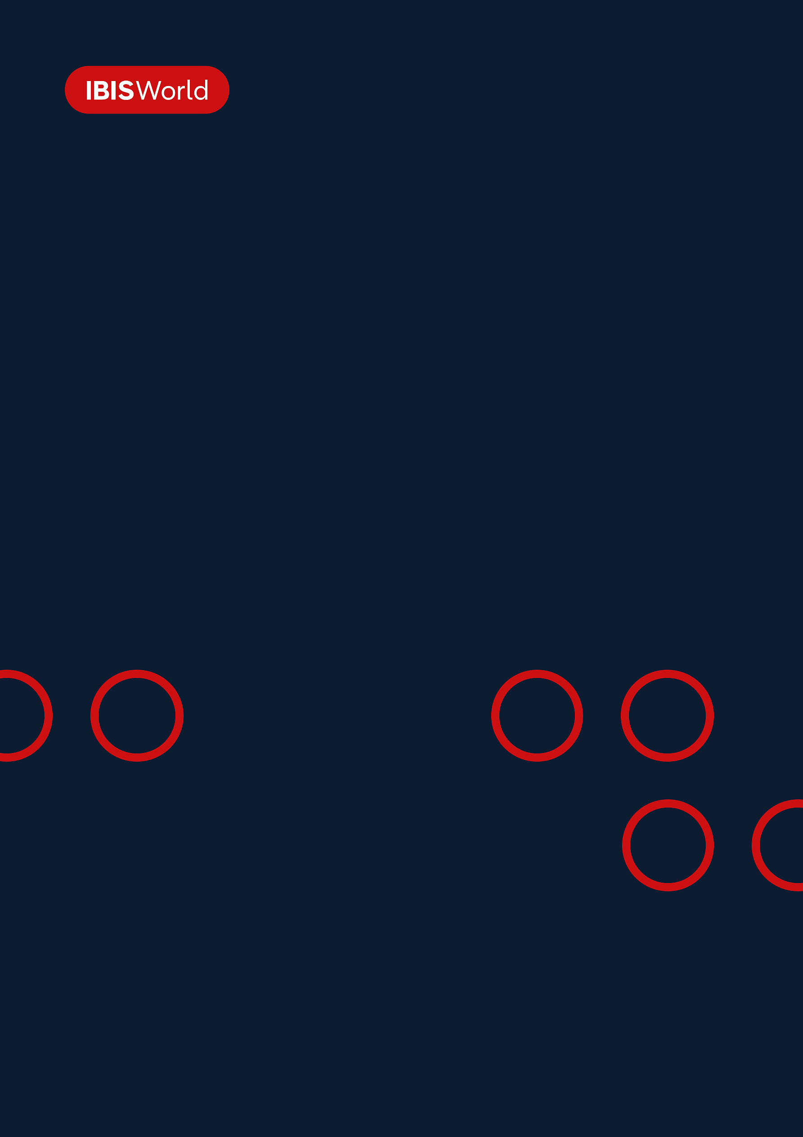
INDUSTRY REPORT
Port & Harbor Operations in the US
Jul 2025

About

IBISWorld
IBISWorld specializes in industry research with coverage on thousands of global industries. Our comprehensive data and in-depth analysis help businesses of all types gain quick and actionable insights on industries around the world. Busy professionals can spend less time researching and preparing for meetings, and more time focused on making strategic business decisions.

Table Of Contents | Standard

1. About 4
Codes 4
Definition 4
Related Terms 4
What's Included 5
Companies 5
Related Industries 5
Additional Resources 6
2. At a Glance 7
Key Takeaways 7
Products and Services 8
Major Players 9
Key External Drivers 10
Industry Structure 10
SWOT 11
Executive Summary 11
3. Performance 13
Highlights 13
Key Takeaways 13
Performance Snapshot 14
Outlook 22
Life Cycle 24
4. Products and Markets 25
Key Takeaways 25
Products and Services 26
Major Markets 30
International Trade 32
5. Geographic Breakdown 33
Key Takeaways 33
Business Locations 34
6. Competitive Forces 43
Key Takeaways 43
Concentration 43
Barriers to Entry 45
Substitutes 46
Buyer & Supplier Power 48
7. Companies 50
Key Takeaways 50
Market Share 51
Companies 52
8. External Environment 63
Key Takeaways 63
External Drivers 63
Regulation & Policy 66
Assistance 68
9. Financial Benchmarks 69
Key Takeaways 69
Cost Structure 70
Financial Ratios 73
Valuation Multiples 79
Key Ratios 80
10. Key Statistics 82
Industry Data 82

1. About
https://my.ibisworld.com/us/en/industry/48831/about

Codes
NAICS 2017 - USA | 48831
NAICS 2017 - USA | 488310
NAICS 2022 - USA | 48831
NAICS 2022 - USA | 488310

Definition
Companies in this industry operate ports, harbors (including docking and pier facilities) or canals. Their main activities include loading and unloading cargo from ships, operating lighthouses, arranging paperwork for incoming shipments, operating computer systems to connect cargo with recipients and providing accommodations to docked vessels.

Related Terms

TEU
Stands for 20-foot Equivalent Unit, which is a measure used in intermodal transport, derived from the original size of a shipping container.

DREDGING
The act of excavating sediments at the bottom and sides of a channel of water to make it wider and deeper.

BULK CARGO
Unpackaged commodity cargo that is transported in large quantities. Examples include wheat, coal and iron ore.

WHARFAGE
The accommodations made for loading, unloading and storing goods provided by ports and harbors.

ELECTRONIC DATA INTERCHANGE (EDI)
Transmission of electronic documents between businesses from one computer system to another.

FOREIGN-TRADE ZONE (FTZ)
Restricted access sites located in or near a US Customs Service port of entry that provides users, such as importers, manufacturers and distributors, with cost savings.

PORTAINER
A container crane used at container terminals for loading and unloading intermodal containers from container ships.

What's Included
- Waterfront terminal operation and maintenance
- Canal operation and maintenance
- Docking facility operations
- Harbor operation and maintenance
- Lighthouse operation
- Port facility operation
- Seaway operation
- Wharf operation

Companies
- Port of Houston Authority
- Port of Los Angeles
- The Georgia Ports Authority
- Port of Long Beach
- The Port Authority Of New York & New Jersey
- The Northwest Seaport Alliance

Related Industries

Industries in the Same Sector
- Competitors:
  - No data available
- Complementors:
  - Stevedoring & Marine Cargo Handling in the US
  - Tugboat & Shipping Navigational Services in the US
  - Dry Dock & Cargo Inspection Services in the US
  - Marinas in the US

International Industries
- Global Marine & Container Terminal Operation
- Ocean & Coastal Transportation in Canada
- Water Freight Transport in Australia
- Port & Water Transport Terminal Operations in New Zealand
- Sea & Coastal Freight Water Transport in the UK
- Sea & Coastal Water Transport in Germany
- Sea & Coastal Freight Water Transport in Germany
- Sea & Coastal Freight Water Transport in Ireland
- Sea & Coastal Water Transport in Ireland
- Sea & Coastal Freight Water Transport in Ireland
- Harbor & Port Operations for Freight in China
- Sea & Coastal Passenger Water Transport in Spain
- Sea & Coastal Freight Water Transport in Spain

Additional Resources
- US International Trade Commission
- American Association of Port Authorities
- US Maritime Administration

2. At a Glance
https://my.ibisworld.com/us/en/industry/48831/at-a-glance
Revenue  $6.0bn  ’21-’26 ↑ 3.6 %  ’26-’31 ↑ 2.7 % | Employees  15,046  ’21-’26 ↑ 3.5 %  ’26-’31 ↑ 2.4 % | Businesses  255  ’21-’26 ↓ 1.1 %  ’26-’31 ↑ 0.7 %
Profit  $786.9m  ’21-’26 ↑ 12.9 % | Profit Margin  12.7%  ’21-’26 ↑ 3.4 pp | Wages  $1.2bn  ’21-’26 ↑ 2.5 %  ’26-’31 ↑ 2.5 %

Key Takeaways

Performance
- E-commerce drove a five-year surge in container volumes. Still, tariff-driven front-loading in early 2025 led to a revenue spike, followed by a sharp correction. Ports that diversified into value-added services were more insulated from supply chain disruptions.
- Federal ESG funding retreated under the Trump administration. This left open the possibility of funding decarbonization through state programs and private partnerships. Ports with voluntary net-zero commitments risk losing sustainability-linked financing if federal support continues to erode.
- Infrastructure Investment and Jobs Act funding runs through late 2026 with no confirmed successor program. This creates a potential funding cliff for modernization. Ports unable to complete automation and capacity upgrades risk falling behind global competitors investing continuously in technology.

Products and Markets
- Dry bulk revenue contracted because China's retaliatory tariffs caused a collapse in US coal and grain exports. Recovery depends on trade policy resolution that is unlikely before mid-2026.
- Liquefied natural gas exports hit record levels in early 2026. This contributed to high berth utilization and bunkering revenue at Gulf Coast ports. This multi-year tailwind is accelerating because new capacity from Cheniere and Venture Global comes online.
- Cruise revenue reached record passenger volumes in 2025 and is forecast to climb further in 2026. This provides one of the few tariff-insulated revenue streams. Ports investing in dedicated cruise infrastructure are capturing a disproportionate share of this growth.
- Vehicle tariffs triggered a brief Ro-Ro surge before volumes contracted sharply. Chinese vehicle imports are nearly disappearing entirely. Equipment manufacturers are likely to continue restructuring US supply chains.

Products and Services
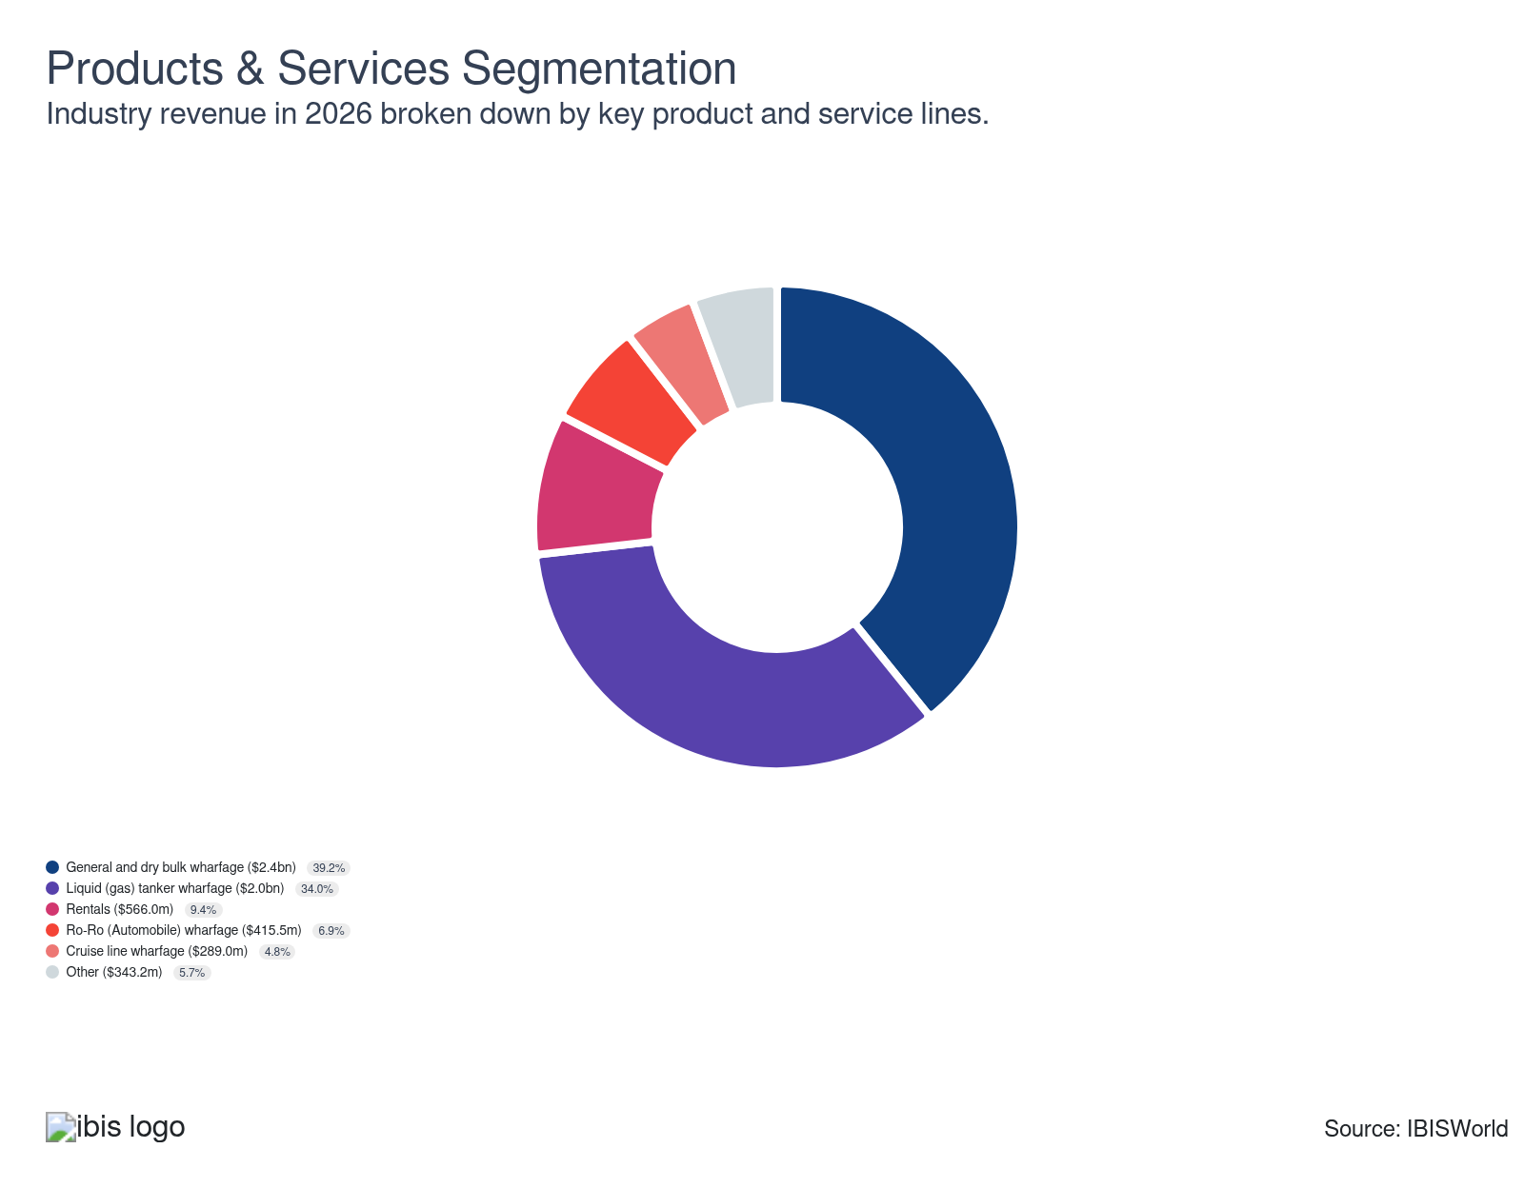

Major Players
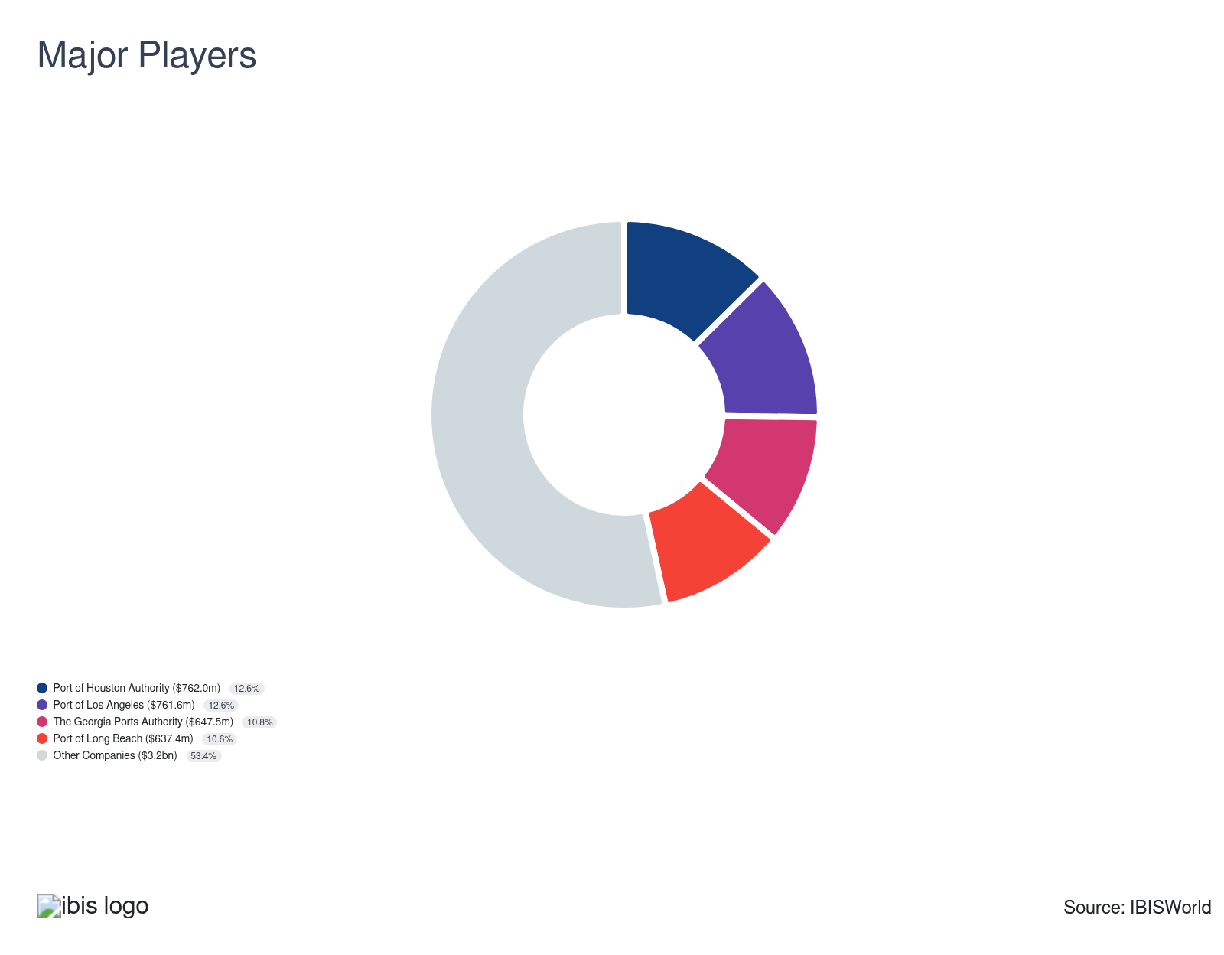

Key External Drivers
Key External Drivers | Impact
Total trade value | Positive
Consumer spending | Positive
Freight transportation services index | Positive
Industrial production index | Positive
Trade-weighted index | Positive

Industry Structure
Characteristic | Level | Trend
Concentration | Moderate
Barriers To Entry | High | Steady
Regulation and Policy | Moderate | Steady
Life Cycle | Mature
Revenue Volatility | Moderate
Assistance | Moderate | Steady
Competition | Moderate | Steady
Innovation | High

SWOT
Strengths  High & Steady Barriers to Entry  Low Imports  High Profit vs. Sector Average  Low Customer Class Concentration  Low Product/Service Concentration  High Revenue per Employee | Weaknesses  High Capital Requirements | Opportunities  High Revenue Growth (2005-2026)  High Revenue Growth (2021-2026)  High Revenue Growth (2026-2031)  High Performance Drivers | Threats  Low Outlier Growth

Executive Summary

Charting uncertain waters: Tariffs and new investments reshape port revenue
US port and harbor operations experienced tariff-driven front-loading, which inflated 2025 volumes. This gave way to a sharper demand correction in the second half of 2025. Wharfage, storage and docking income fluctuated similarly. Tariffs on finished vehicles and levies on Chinese goods reduced container import volumes year over year in early 2026. The ILA's ratified six-year contract embedded a wage increase retroactive to October 2024. This simultaneously raised costs across East and Gulf Coast terminals. It also reduced profit even as revenue briefly spiked. Profit has nonetheless improved steadily over the current period, rising from 9.3% in 2021 to 12.7% in 2026. This was because of efficiency gains from automation, cloud-based terminal operating systems and value-added services. Higher demand for warehousing, transloading and cold storage all enabled providers to charge higher fees and generate more profit. Port and harbor revenue climbed at a five-year CAGR of 3.6%, reaching $6.0 billion and increasing 2.0% in 2026. This was supported by e-commerce-driven import growth, liquefied natural gas (LNG) export expansion and the post-pandemic cruise recovery.
The competitive structure shifted meaningfully during this period. Volume was redistributed away from legacy West Coast and Northeast gateways toward the Southeast and Gulf Coast. The Port of Savannah posted its second-busiest year on record in 2025. At the same time, the Port of Corpus Christi set first-quarter tonnage records in 2026. This reflects how diversified cargo mixes and energy infrastructure advantages reshape regional competitiveness.
Meanwhile, global carriers accelerated the consolidation of terminal ownership. Carrier-owned infrastructure is becoming the dominant competitive model. Federal funding uncertainty also becomes a reality for providers. No new funds will be issued under the Infrastructure Investment and Jobs Act after September 2026. This could reduce smaller ports' ability to modernize infrastructure and incorporate automation.
Moderate but more stable growth is likely if tariff policy gradually eases. Nearshoring trends redirect new freight flows through the Gulf and Southeast gateways. LNG export capacity additions could also sustain energy-related wharfage revenue through 2031. The trade-weighted dollar's recent depreciation supports a gradual recovery in export volumes. At the same time, e-commerce growth could expand bunkering revenue at coastal terminals. Profit will reach 14.7% by 2031 because fixed infrastructure costs continue to amortize and value-added service revenue increases. Revenue is expected to climb at a five-year CAGR of 2.7%, reaching $6.9 billion by 2031.

3. Performance
https://my.ibisworld.com/us/en/industry/48831/performance

Highlights
Revenue  $6.0bn  2021-26 CAGR ↑ 3.6 %  2026-31 CAGR ↑ 2.7 % | Employees  15,046  2021-26 CAGR ↑ 3.5 %  2026-31 CAGR ↑ 2.4 % | Businesses  255  2021-26 CAGR ↓ 1.1 %  2026-31 CAGR ↑ 0.7 %
Profit  $786.9m  2021-26 CAGR ↑ 12.9 % | Profit Margin  12.7%  2021-26 CAGR ↑ 3.4 pp

Key Takeaways
- E-commerce drove a five-year surge in container volumes. Still, tariff-driven front-loading in early 2025 led to a revenue spike, followed by a sharp correction. Ports that diversified into value-added services were more insulated from supply chain disruptions.
- Federal ESG funding retreated under the Trump administration. This left open the possibility of funding decarbonization through state programs and private partnerships. Ports with voluntary net-zero commitments risk losing sustainability-linked financing if federal support continues to erode.
- Infrastructure Investment and Jobs Act funding runs through late 2026 with no confirmed successor program. This creates a potential funding cliff for modernization. Ports unable to complete automation and capacity upgrades risk falling behind global competitors investing continuously in technology.

Performance Snapshot
Revenue: | ↑ 2021-26 Revenue CAGR +3.6%
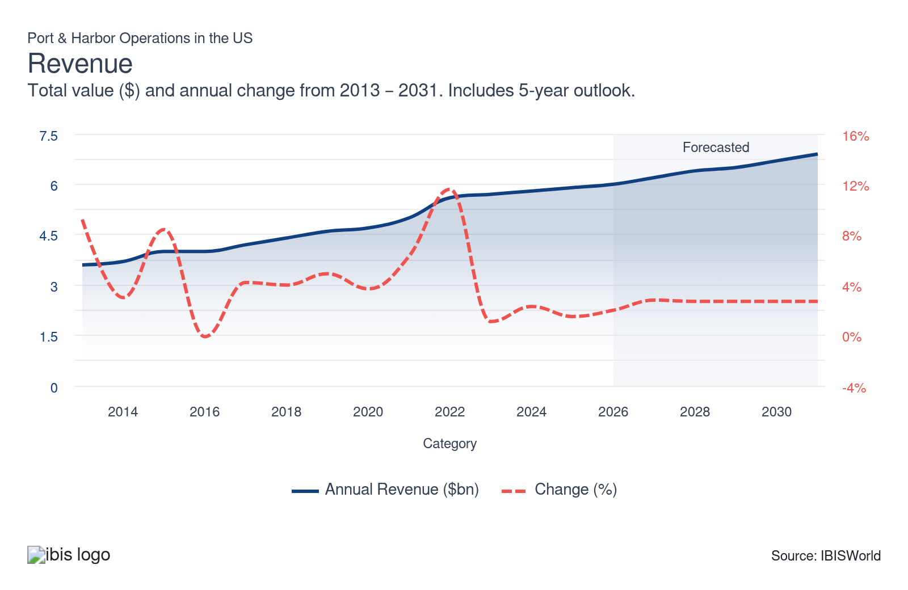
Employees: | ↑ 2021-26 Employees CAGR +3.5%
Employees  15,046  ’21-’26 ↑ 3.5 %  ’26-’31 ↑ 2.4 % | Employees per Business  59  ’21-’26 ↑ 4.6 %  ’26-’31 ↑ 1.7 % | Revenue per Employee  $400k  ’21-’26 ↑ 0.1 %  ’26-’31 ↑ 0.3 %
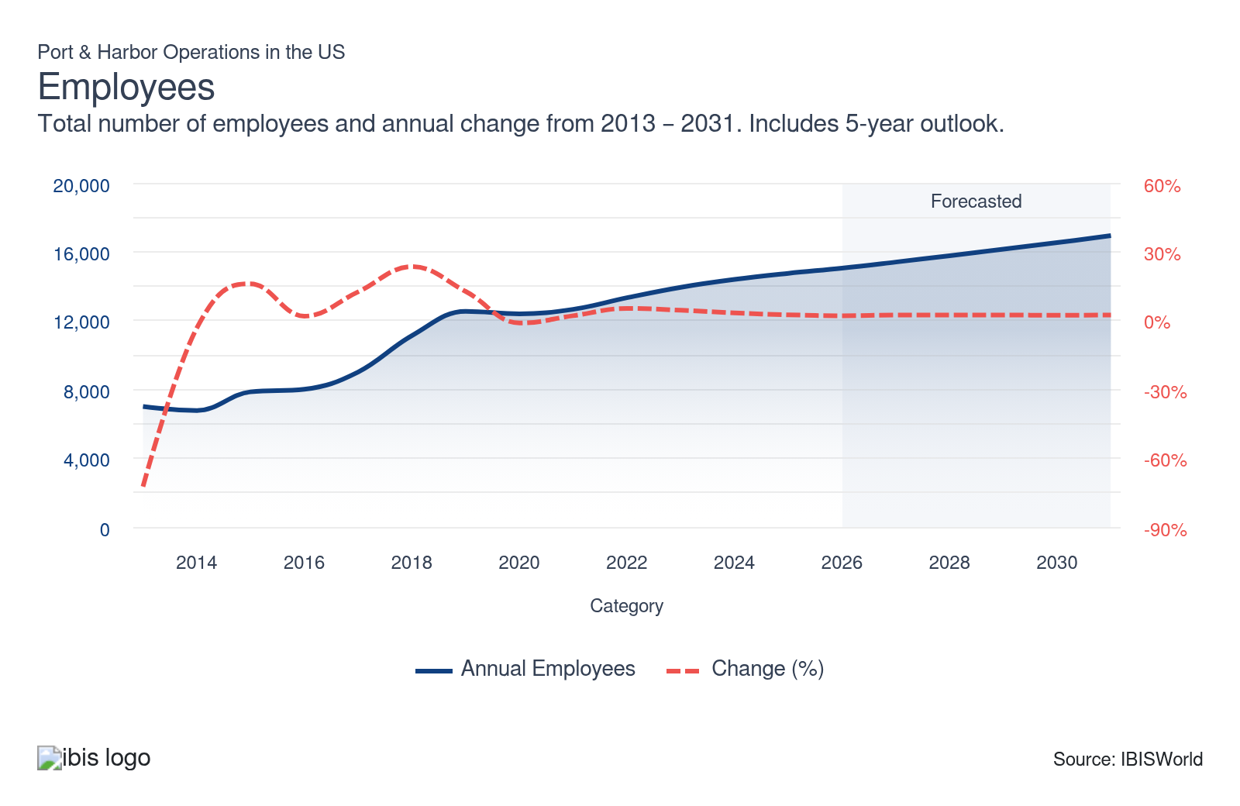
Businesses: | ↓ 2021-26 Business CAGR -1.1%
Businesses  255  ’21-’26 ↓ 1.1 %  ’26-’31 ↑ 0.7 % | Employees per Business  59  ’21-’26 ↑ 4.6 %  ’26-’31 ↑ 1.7 % | Revenue per Business  $23.6m  ’21-’26 ↑ 4.7 %  ’26-’31 ↑ 2.0 %
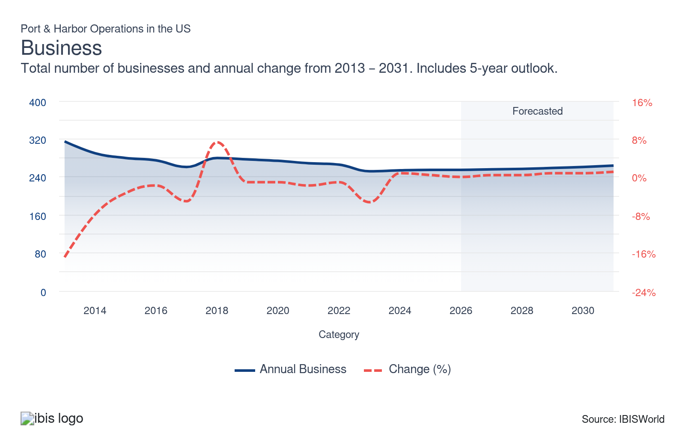
Profit: | ↑ 2021-26 Profit CAGR +12.9%
Total Profit  $786.9m  ’21-’26 ↑ 12.9 % | Profit Margin  12.7%  ’21-’26 ↑ 3.4 pp | Profit per Business  $3.0m
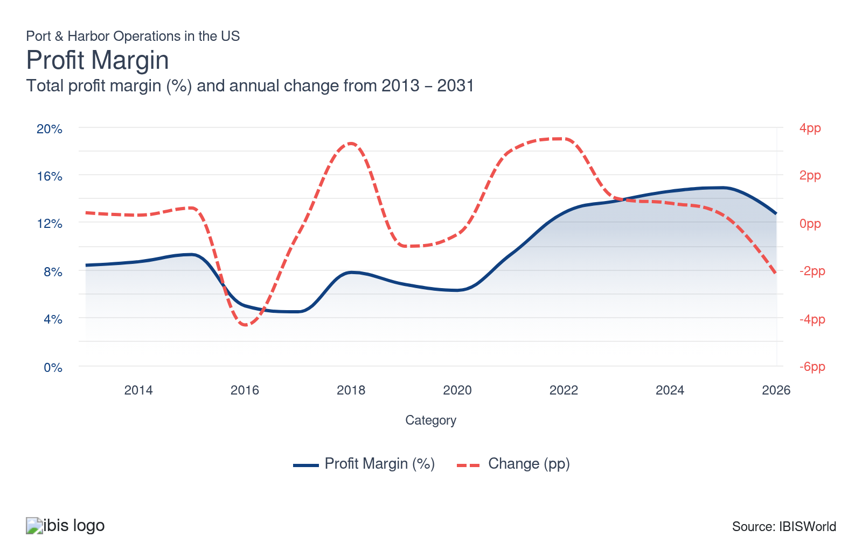
Current Performance
Current Performance

What's driving current industry performance?

E-commerce contributed to higher import volumes and port revenue
- Over the past five years through 2026, e-commerce drove a surge in inbound container volumes at US ports, particularly for electronics and apparel. This prompted providers to expand infrastructure and invest in automated handling and digital logistics systems. This demand fueled revenue growth across major hubs, which responded by layering in higher-profit storage and value-added services alongside core throughput activity.
- That e-commerce dependency became a liability when new tariffs and rising supply chain costs hit. Port sensitivity to trade conditions sharpened, and revenue volatility followed. The Port of Los Angeles handled 12.0% fewer TEUs year-over-year in January 2026, according to port data. This is because front-loaded 2025 shipments drained the pipeline.
- Ports that leaned heavily on consumer goods imports now face a more fragmented freight landscape. Container import volumes for the first half of 2026 are forecast to drop 2.5% from 2025 levels, according to Global Port Tracker. This suggests that providers that fail to diversify cargo mix could transport less bulk, breakbulk or industrial freight. This risks prolonged revenue pressure because e-commerce trade flows remain unstable.

The federal retreat from ESG funding reduces port revenue
- US ports made significant clean energy commitments over the past decade. The Port of Virginia became the first US East Coast port powered by 100.0% clean electricity on January 1, 2024. This reduced its carbon footprint by 45.0% per container handled, according to the Port of Virginia. The Port of Los Angeles, the Port of New York and the Port of New Jersey followed with similar initiatives and began publishing formal ESG reports.
- The Trump administration's withdrawal from the Paris Agreement and rollback of federal sustainability incentives weakened the financial case for those investments. ESG-focused capital pools are contracting and ports now face a funding gap precisely when aging infrastructure needs replacement and climate-driven storm and sea-level risks are growing.
- Ports that relied on federal tax credits and green subsidies to justify decarbonization projects may delay or cancel planned upgrades. If federal support recedes and reporting mandates loosen, service providers with voluntary ESG commitments may quietly scale back transparency. This reduces their ability to attract sustainability-linked financing. It also potentially reduces the competitive ground to foreign ports that continue to invest in sustainability infrastructure.

Port infrastructure development continues to depend on government funding
- The US Maritime Administration (MARAD) opened another funding round in March 2026 through the Port Infrastructure Development Program. Applications are due June 26, 2026, according to MARAD. The program is funded through the Infrastructure Investment and Jobs Act (IIJA). A quarter of the available funding is also reserved for small port projects.
- While the grant round offers near-term relief, it does not resolve the structural challenge. The $2.25 billion IIJA allocation runs through September 30, 2026, with no guaranteed successor funding. MARAD also continues to face high vacancy rates and experienced staff nearing retirement. Global port competitors are investing continuously in automation and capacity. This widens the efficiency gap.
- If Congress does not authorize a new multi-year maritime infrastructure bill, ports could face a funding cliff after 2026 that stalls mid-cycle automation projects. Ports that cannot complete planned upgrades risk higher per-move costs, longer vessel turnaround times and growing carrier frustration. These outcomes could redirect cargo to rival hubs with more reliable operations.

Tariff frontloading masked underlying port revenue weakness
- Tariff front-loading pushed 2025 into a record year of imports at several major gateways. This temporarily inflated port and harbor operations profit. According to the US Bureau of Economic Analysis, customs collections increased 217.2% year-over-year in 2025. That benefit flowed to the government rather than port providers. The surge also masked fixed-cost exposure that became visible once volumes contracted.
- When tariffs took hold and retaliatory measures hit US exports, throughput at Gulf and Atlantic ports dropped sharply. US container imports dropped 6.7% year-over-year in January 2026, according to the National Retail Federation. This leaves facilities underutilized and per-unit costs rising. Ports like New York and New Jersey have pushed tenants to make larger infrastructure commitments and seek bigger shares of terminal transfer revenue to offset the gap.
- Without a recovery in trade volumes or a policy shift that stabilizes import demand, ports face a prolonged period of underused capacity and reduced profit. Carriers may increasingly route cargo through foreign ports with lower congestion costs. Providers that cannot lock in long-term lease revenue through renegotiated agreements risk revenue stagnation even if global container trade gradually recovers through 2027.

What influences industry volatility?

Tariff swings and shifting traffic patterns create unpredictable revenue cycles for industry
- Port revenue has become increasingly volatile in 2026 because tariff policy and carrier competition reshape cargo flows. Sudden tariff hikes and global disputes triggered a surge in import activity. Sharp drops in ship calls and cargo volumes followed afterward. At the same time, ocean carriers formed shifting alliances and regularly switched ports to secure better rates or incentives. They often bypassed traditional gateways when capacity or local costs did not align with their strategies.
- This pattern left port managers with less profit from wharfage and storage fees. High fixed costs made it tough to adjust quickly when volumes dropped. Lost market share also delayed efforts to maintain facilities and invest in upgrades that are needed for larger vessels and modern cargo handling.
- Successful ports will likely strengthen contracts with terminal tenants and pursue incentives that encourage loyalty. They may also continue to adapt pricing to reflect fluctuations in volumes. A diverse cargo mix and investment in digital systems also provide real-time insight into market shifts. They collaborate closely with shipping alliances and could be essential for managing volatility in the years ahead.

Strikes and aging berths created revenue volatility across ports
- Unlike more domestically focused sectors like trucking or rail, port revenue is directly exposed to global trade volatility. Disruption from International Longshoremen's Association strikes caused sudden swings in volumes and wages in early 2025. Each standoff triggered cargo diversions to West Coast and Canadian ports. Shippers of discretionary, time-sensitive goods absorbed the rerouting costs and revenue losses at terminals after operations resumed.
- Aging infrastructure increased volatility. A climb in vessels because of an increase in trade value suggests ports are utilizing a greater percentage of their maximum capacity. Many berths in the US continue to lack the depth, crane height and yard capacity to accommodate more ships, however. This extends backlogs that formed during the labor standoffs. It also drives up congestion surcharges and overtime labor costs for providers.
- Rising per-move labor costs and union resistance to automation could leave ports at a competitive disadvantage compared to automated West Coast and foreign hubs. Vessel sizes and volume demands will still likely climb through 2026 if trade increases.
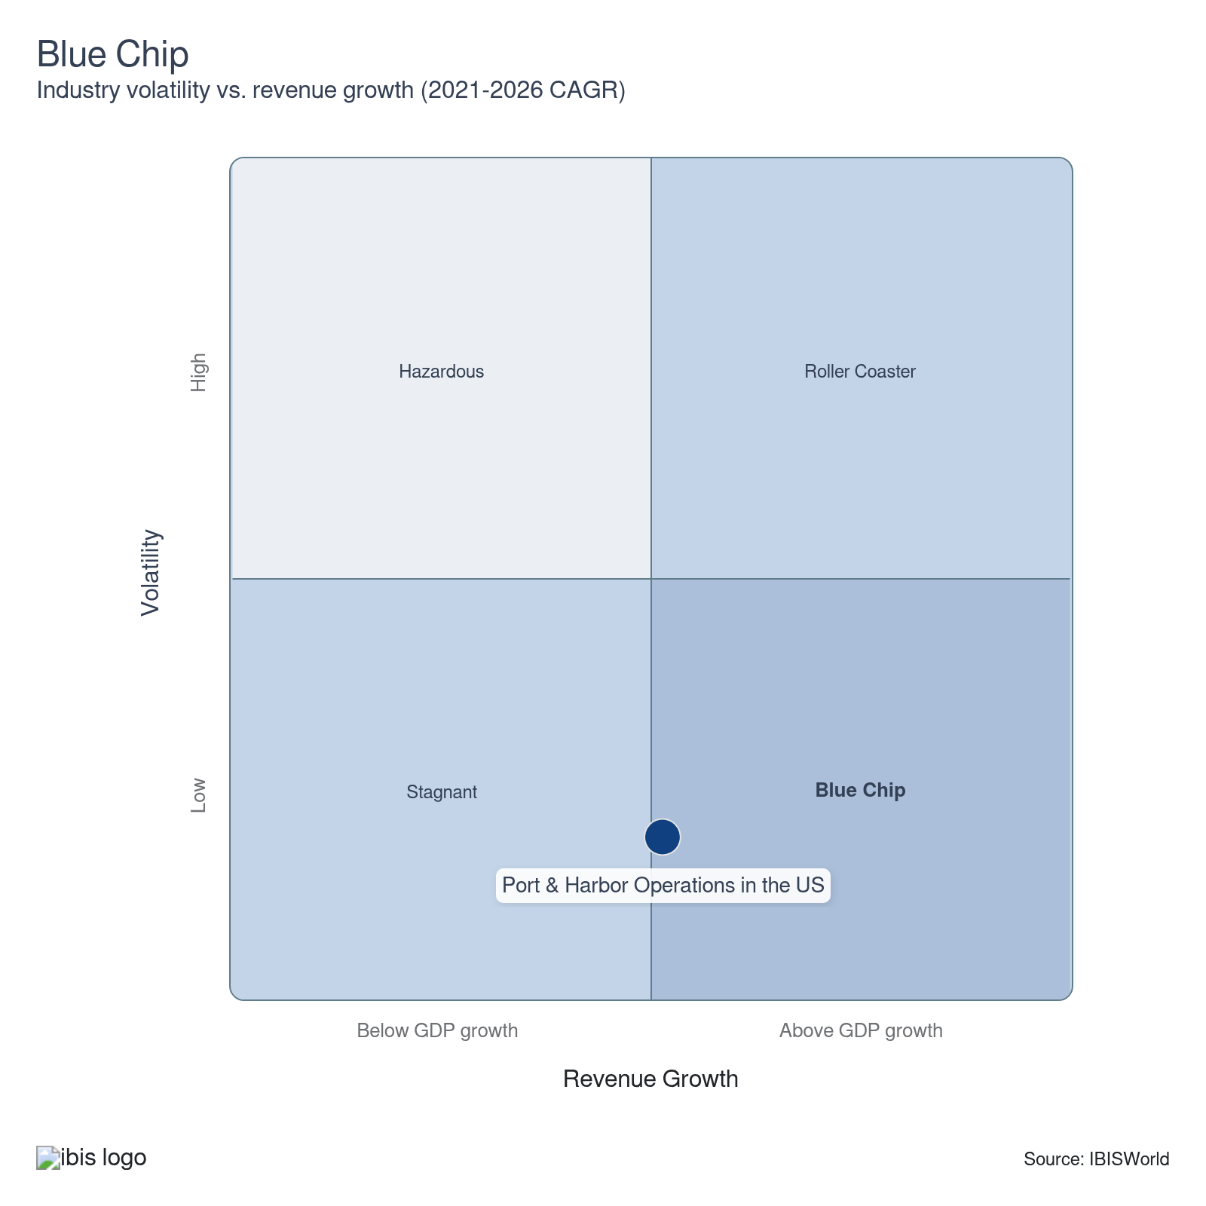

How do successful businesses overcome volatility?
Secure export markets
Expanding into export markets diversifies revenue streams, reduces dependence on domestic demand and helps balance economic fluctuations in the US.
Implement superior financial management and debt management
Strong financial and debt management practices provide liquidity and creditworthiness to withstand economic downturns. These funds are essential for operations during volatile periods.
Have a diverse range of clients
Although customer permits usually run for many years, some shipping lines may still move to terminals that offer better handling rates or incentives. Maintaining a diverse client base helps providers protect revenue if individual clients decide to switch terminals.
Outlook | ↑ 2026-31 Revenue CAGR +2.7%

What's driving the industry outlook?

Infrastructure investment will likely drive measured but uneven port revenue growth
- A recovery in volumes for 2026 depends on whether trade policy uncertainty clears. US container imports are forecast to remain below 2025 levels in the first half of 2026, according to Global Port Tracker. Still, the trade value will likely recover because shippers could rebuild depleted inventories. Ports with energy, agricultural bulk and breakbulk may generate more revenue than those still reliant on consumer goods imports.
- The Trump administration's fiscal year 2027 budget continued to rely on Harbor Maintenance Trust Fund revenues for navigation dredging and did not significantly expand discretionary port funding. This left revenue upside tied more to throughput recovery than federal investment.
- Fitch maintained a stable outlook on the Port of Los Angeles Harbor Department's revenue bonds in April 2026. They cited resilient long-term demand even as near-term volumes softened. This suggests that major gateway ports could preserve revenue floors through lease structures even during cargo downturns. If trade policy stabilizes by mid-2026, a volume rebound in the second half positions total revenue to climb modestly in 2026 before accelerating in 2027.

The International Longshoremen's Association's wage deal increases wages at ports
- The International Longshoremen's Association's (ILA) six-year contract, ratified in February 2025 and retroactively effective October 1, 2024, raises the base hourly rate by 62.0%. This could reduce turnover for ports along the Atlantic and Gulf Coasts, where most ILA employees are located. However, a sustained wage hike could raise operating costs for ports through September 2030.
- The contract also blocks automation of ILA-represented jobs, limiting providers' ability to offset labor cost increases with technology. The unemployment rate in the transportation sector dropped 1.2% year over year in March 2026, according to the BLS. This is also below the national unemployment rate of 4.3%, suggesting a tightening labor market for port workers. This gives the ILA sustained leverage and makes further wage escalation likely at the next contract negotiation.
- Providers that struggle to pass higher labor costs through wharfage and terminal fees risk lower profit through 2031. Ports that invest in technology-compatible workflows may be better positioned to generate productivity gains without triggering further labor conflicts.

Automation and volume uncertainty limit employee growth
- The ILA contract's wage progression for new hires was explicitly designed to address an aging workforce and attract younger workers to physically demanding roles. This is likely to support moderate headcount growth at unionized East and Gulf Coast terminals.
- However, the contract's full prohibition on automation at ILA-represented facilities reduces productivity-per-worker gains. This could reduce the need for providers to expand headcount beyond what volume growth strictly requires. Transportation and warehousing sector employment also dropped 1.8% year-over-year as of March 2026, according to the BLS. This reflects caution across the broader supply chain amid trade uncertainty. Slower employment growth across port and harbor operations is likely to follow over the next five years through 2031.
- Providers not subject to the ILA agreement will likely deploy semi-automated equipment to reduce wages. This could increase the number of crane remote operators, systems monitors and logistics analysts. At the same time, automation could reduce the number of traditional frontline positions. Total employment will likely climb slowly even if port activity accelerates through 2031.

Consolidation could lead to service differentiation across ports
- MSC's proposed $23.0 billion acquisition of CK Hutchison's global terminal portfolio could create the world's largest terminal provider. This deal suggests that global shipping lines are aggressively internalizing terminal ownership to secure berth access and reduce dependence on independent providers.
- In the US, this deal could pressure independent port authorities to compete for carrier loyalty through long-term lease incentives, infrastructure co-investment and service differentiation. The five largest terminal providers already collectively accounted for 52.0% of global gross throughput, according to Drewry. Concentration could increase if M&A activity increases through 2026 and 2027.
- Smaller US port authorities that cannot offer competitive lease terms or reliable infrastructure could lose larger, consolidated providers. At the same time, major harbor service providers that successfully lock in long-term volume commitments may generate more predictable revenue streams.
Life Cycle | Mature

Why is the industry mature?

Contribution to GDP
Port and harbor operations in the US are expected to climb faster than the overall GDP. This was driven by expanding global trade activity and robust federal and state investment in port infrastructure. The adoption of automation and advanced logistics technologies further increases this contribution.

Market Saturation
US ports operate in a geographically constrained market. Coastlines, rivers and navigable waterways are finite. Major port locations are also long-established. Growth is driven by throughput efficiency gains at existing facilities rather than the creation of net-new port infrastructure. This suggests the market is mature and saturated.

Innovation
Automation, AI-driven logistics and digital freight platforms are redefining operational benchmarks. Innovation is competitive rather than disruptive here. It enhances speed and capacity within existing facilities rather than threatening the fundamental structure. This reflects a mature sector contributing to growth through technology adoption.

Consolidation
Coastal port providers operate from single ports and harbors along international trade routes. Consolidation increased during periods of lower liquidity. However, concentration is unlikely to increase under stable market conditions because of geographic barriers. High capital requirements, long permitting timelines and strategic national security considerations also prevent consolidation.

Technology & Systems
New sensors, automated cranes, blockchain-based documentation and real-time vessel tracking are among the technologies used by ports and harbors. Rather than replacing the need for ports, technology deepens operational lock-in and raises the switching costs for shipping lines and logistics partners. This systems-level investment suggests ports operate in a mature market.

4. Products and Markets
https://my.ibisworld.com/us/en/industry/48831/products-and-markets
Largest Market  $2.4bn  General and dry bulk wharfage | Product Innovation  High

Key Takeaways
- Dry bulk revenue contracted because China's retaliatory tariffs caused a collapse in US coal and grain exports. Recovery depends on trade policy resolution that is unlikely before mid-2026.
- Liquefied natural gas exports hit record levels in early 2026. This contributed to high berth utilization and bunkering revenue at Gulf Coast ports. This multi-year tailwind is accelerating because new capacity from Cheniere and Venture Global comes online.
- Cruise revenue reached record passenger volumes in 2025 and is forecast to climb further in 2026. This provides one of the few tariff-insulated revenue streams. Ports investing in dedicated cruise infrastructure are capturing a disproportionate share of this growth.
- Vehicle tariffs triggered a brief Ro-Ro surge before volumes contracted sharply. Chinese vehicle imports are nearly disappearing entirely. Equipment manufacturers are likely to continue restructuring US supply chains.

Products and Services
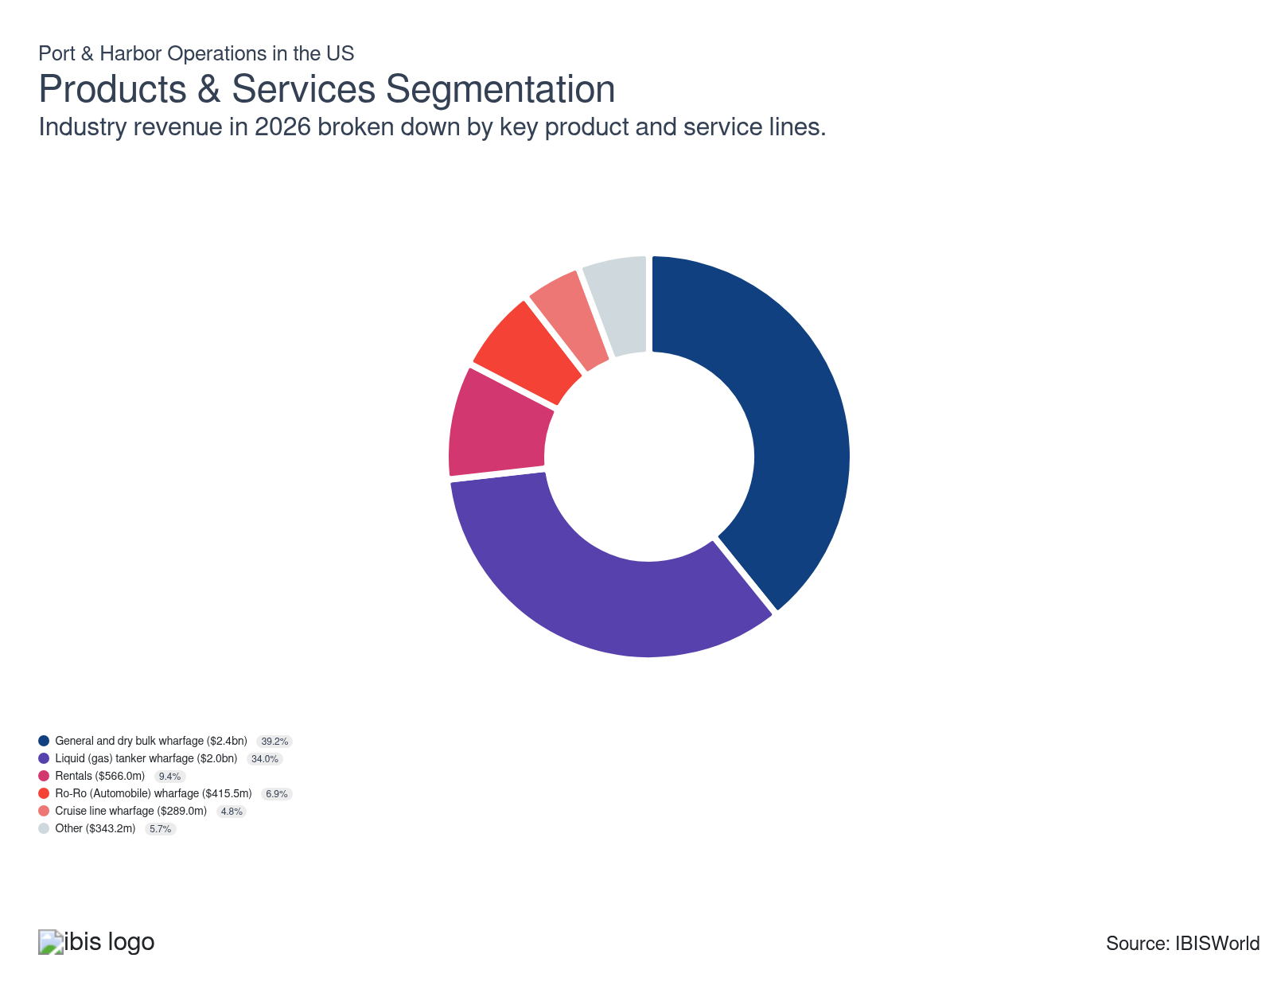

How are the industry’s products and services performing?

China's retaliatory tariffs reduced dry bulk revenue
- Essential imports, such as food and consumer goods, remain the drivers of storage and container revenue in 2026. A 50.0% increase in steel and aluminum tariffs in 2025 also raised the cost of construction inputs. Tariffs could continue to reduce drybulk revenue in 2026.
- According to the Energy Information Administration (EIA), US coal exports fell 14.5% in 2025. This was driven by a 92.0% collapse in shipments to China after Beijing imposed cumulative tariffs of up to 49.0% on US coal. Agricultural bulk exports also faced international pressure. Still, dry bulk freight rates dropped because global supply outpaced rerouted demand. The EIA has not confirmed whether coal export volumes will recover in 2026, so ports may face more headwinds.

Liquefied Natural Gas (LNG) exports contributed to more liquid tanker revenue
- According to the Energy Information Administration, liquefied natural gas (LNG) exports surged in 2025 and 2026. This generated substantial revenue from liquid tankers. The EIA also forecasts a climb in LNG volumes for 2027 because new Gulf Coast capacity.
- This export surge is driving sustained berth utilization and LNG bunkering revenue at major Gulf Coast ports. LNG-fueled global vessel fleets are likely to also expand. This could generate multi-year tailwinds in revenue for ports equipped with cryogenic infrastructure. Oversupplied crude tanker markets may apply modest offsetting pressure.

Diversification into rental and bunkering services stabilizes port revenue
- Rental and storage facilities include land, warehouses, wharves and sheds leased to shipping customers and freight transport providers. These provide a growing revenue buffer when container throughput faces cyclical headwinds. Gulf Coast ports maintained consistent product availability and competitive pricing throughout trade volatility. The Department of Energy's February 2025 regulatory clarification removed the authorization for ship-to-ship liquefied natural gas (LNG) transfers at US ports. This further opened the bunkering revenue channel at coastal terminals.
- Ports diversifying into bunkering nodes for LNG, methanol and ammonia create a new valuation premium. Still, the capital-intensive construction requirements for cryogenic storage and safety zones pose a barrier to service differentiation. If container storage demand softens through mid-2026 because of tariffs, rental revenue growth could concentrate at ports with LNG export buildout. Terminals reliant on consumer goods storage could continue to face tariff pressures through 2026.

Vehicle tariffs triggered a front-loading spike before roll-on/roll-off (Ro-Ro) volumes plunged
- Roll-on/roll-off (Ro-Ro) ships are specifically designed vessels capable of carrying wheeled cargo like cars, trucks, trailers and other heavy machinery. Ports equipped with Ro-Ro ship terminals typically require extensive parking areas, ramps and berths designed to accommodate the high traffic volume. Revenue from auto wharfage remains significant, fueling port income through a mix of wharfage charges, storage fees and related specialized services.
- The Trump administration's 25.0% tariff on all imported finished vehicles, effective April 3, 2025, caused a brief surge at Ro-Ro terminals. OEMs rushed shipments into US ports before the deadline. This contributed to higher throughput at Brunswick, Jacksonville and Baltimore. Post-deadline arrivals dropped sharply. Chinese vehicle imports effectively disappeared in 2025, according to West Coast Shipping.
- Ro-Ro revenue share remained stable year-over-year in 2026, but that stability masks significant churn because OEMs accelerate US sourcing to avoid tariffs. Ro-Ro revenue could drop if trade deals fail to reduce the tariff burden on major vehicle-exporting nations through 2026.

Climbing lift docking and provisioning fees contribute to higher revenue from cruises
- Cruises use ports primarily as docking stations where passengers can embark and disembark. Ports also serve as logistical hubs. This facilitates the supply of provisions like food, fuel and water. It also enables the transfer of waste and sewage. Ports and harbors are also used for the repair and maintenance of cruise ships.
- Unlike container volumes, cruise revenue is largely insulated from tariff policy. This makes it one of the few product segments where port providers can forecast revenue growth with confidence. Ports investing in dedicated cruise terminals and faster shoreside connectivity are best positioned to gain market share.
- In 2025 and early 2026, major providers reported near-full ships and strong net yields driven by onboard spending and fare rates growth. Interest remains high among repeat travelers and a climbing number of first-time cruisers. This, in turn, leads to more revenue for port and harbor providers.

What are innovations in industry products and services?

Electrification shifts from climate goal to competitive necessity at US ports
- Many container volumes flow through terminals committed to net-zero emissions by 2050. The Trump administration's April 2025 executive order reaffirmed federal investment in port modernization. The EPA's Clean Ports Program continues to fund the electrification of cargo equipment and the development of zero-emission truck corridors at major hubs.
- Federal funding freezes since 2025 have forced ports to pivot toward state programs, utility partnerships and private investment models to sustain electrification timelines. Ports that secure grid upgrades and battery storage systems gain a competitive edge by benefiting from lower per-move costs, faster equipment cycles and stronger ESG credentials. This attracts shipping lines operating under strict emissions compliance frameworks.

AI and automation are redefining how ports manage cargo
- AI-powered predictive maintenance and asset tracking technology enabled port providers to test yard configurations before physical deployment. Automated stacking cranes, Automated Guided Vehicles and drone inspections are enabling non-stop operations. This reduces vessel turnaround times and lowers cost-per-move even as volumes fluctuate.
- Port automation solutions are also being accelerated by 5G integration. This enables real-time control of remote equipment at scale. It also streamlines communication between terminal providers, truckers and customs agents. AI deployment could increase across fleet scheduling, cargo forecasting and emissions monitoring. This is likely to give early adopters a durable productivity advantage over competitors.

Surging maritime cyberattacks force ports to treat digital security as core infrastructure
- Maritime cyber incidents surged over the last five years through 2026. DDoS attacks, ransomware and malware infections accounted for the majority of breaches. Ports are becoming digitally interconnected through sensors, automated cranes and cloud-based logistics platforms. This makes them more vulnerable to attacks, which poses a risk to revenue.
- The US Coast Guard's final cybersecurity rule for the Marine Transportation System took effect July 16, 2025. It established mandatory minimum requirements for ports and terminals. This included incident reporting and controls on vessel movements to mitigate cyber threats. Ports that fail to meet security certification requirements risk denying port entry to non-compliant vessels. This could reduce throughput and make compliance spending a necessity.

What products or services do successful businesses offer?
Comply with required product standards
Adhering to regulatory standards ensures smooth operations, avoids costly penalties and enhances the port's reputation for reliability and safety in handling goods.
Leverage economies of scope
Expanding service offerings, such as logistics, warehousing and maintenance, maximizes resource utilization, reduces overall costs and attracts a broader range of clients. This enhances the port's market position.

Major Markets
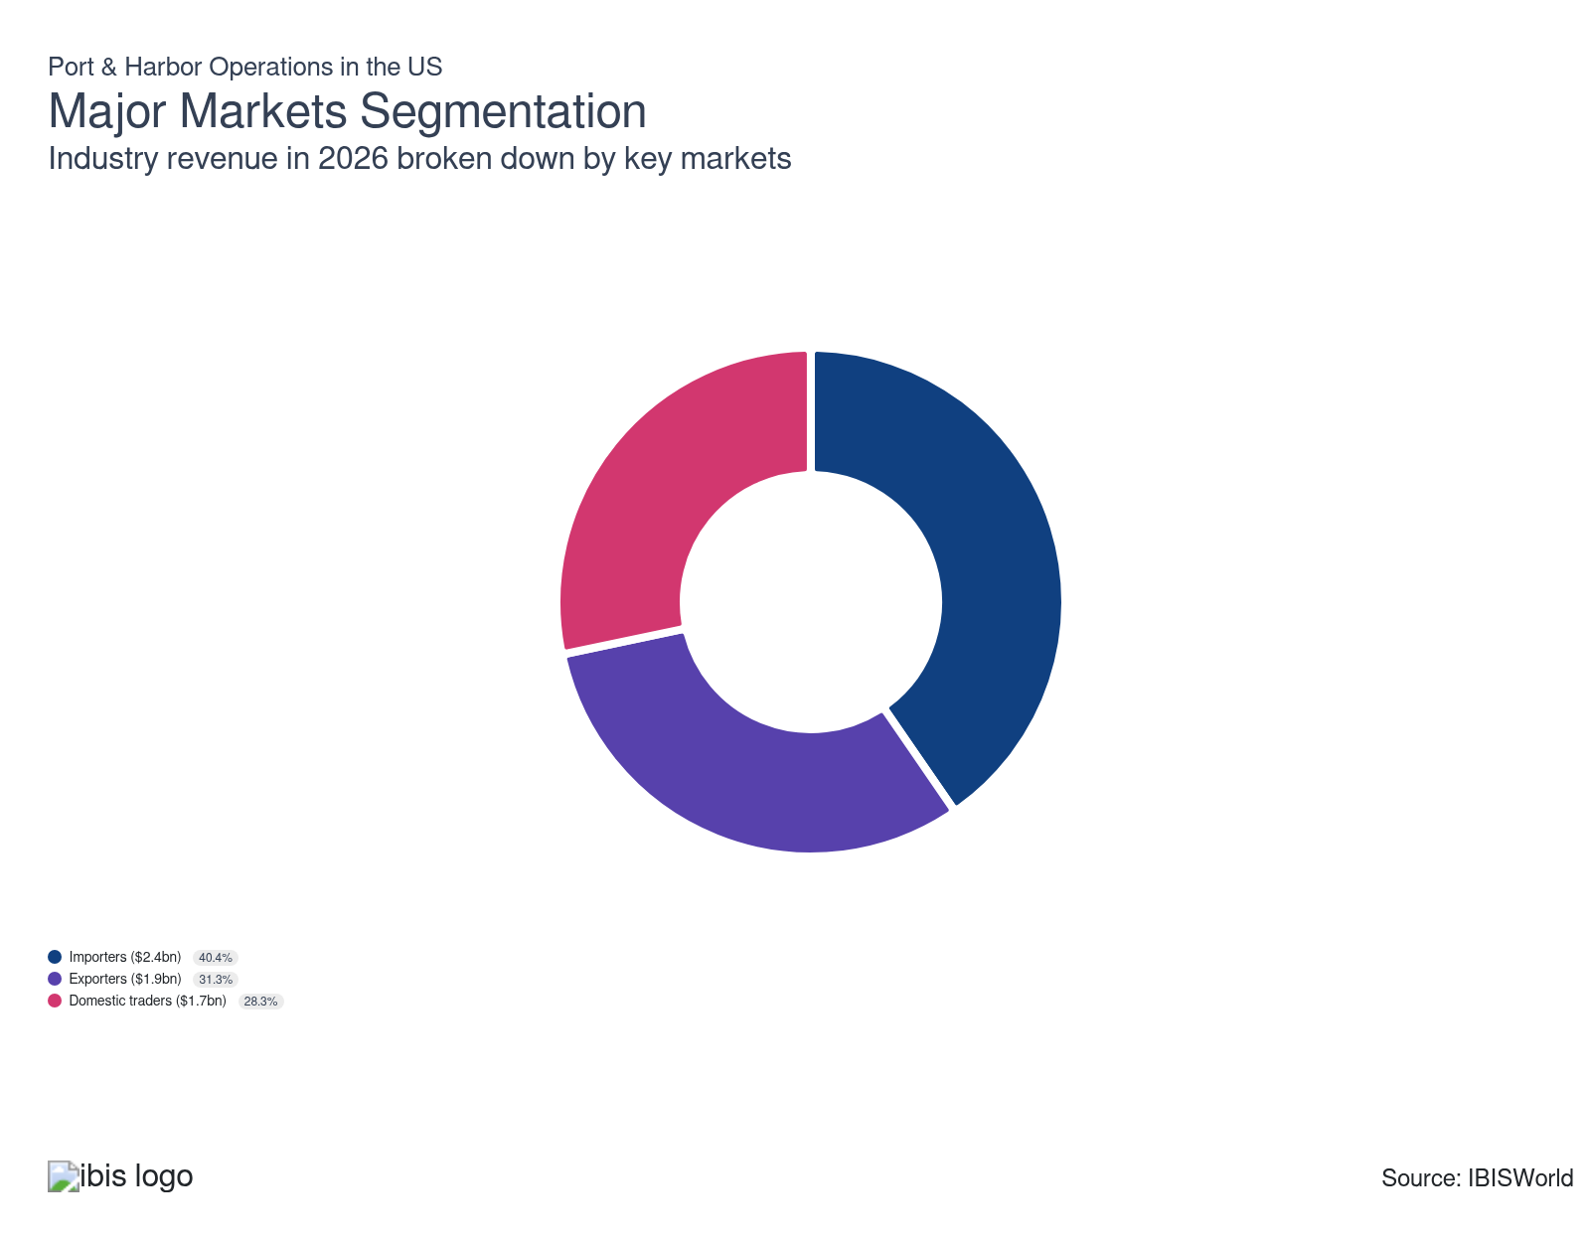

What’s influencing demand from the industry’s markets?

Tariff front-loading reduced domestic inland port activity through 2025
- A brief surge in port activity was driven by shippers rushing inventory ahead of new tariffs. This masked an underlying contraction in domestic trade flows. Average US tariff rates increased in 2025. Many of those costs were passed through to importers. Higher input costs and persistent inflation also weighed on demand from manufacturers and retailers. This prompted leaner inventory strategies and slower shipment rates through inland distribution networks.
- Consumer confidence and GDP growth softened because tariff-driven price increases took hold. This reduced throughput at inland ports connected to the Great Lakes, river and canal waterways. Truck traffic at the Laredo customs checkpoint surged year-over-year in March 2025 because shippers accelerated cross-border movements. Ports that had invested in intermodal rail and transloading flexibility held up better when volumes dropped in the second half of 2025.

A tariff-driven import surge in early 2025 gave way to flat volumes
- Shippers front-loaded container imports at the start of 2025 to beat incoming tariffs. This created a sharp but short-lived volume spike at major US gateways before post-tariff demand compression flattened throughput for the remainder of the year. The surge masked an important structural shift. Retailers and manufacturers began actively diversifying away from Chinese suppliers toward Southeast Asian and South Asian sourcing countries. This trend reshaped which trade lanes flow through US ports.
- Looking ahead to 2026, import volumes are likely to remain below 2025 levels through the first half of the year because the post-front-loading effect of tariffs persists. Retailers are likely to keep inventories lean amid continued trade uncertainty. Ports that invested in flexible intermodal connections and transloading infrastructure are better positioned to capture cargo rerouted from other routes. Global sourcing patterns continue to shift away from China-dominant supply chains.

Retaliatory tariffs and a strong dollar reduced US export volumes through most of 2025
- US waterborne exports faced many headwinds in 2025. Retaliatory measures from major trading partners, particularly China, targeted agricultural commodities and manufactured goods. At the same time, a persistently strong dollar made all US exports more expensive for foreign buyers regardless of direct tariff exposure. Agricultural export corridors were also impacted. If new contracts are established, port service revenue from exports could increase through 2026.
- When import volumes recovered faster than exports in the second half of 2025, pressure on the revenue mix at ports increased. Tariff uncertainty will likely continue to create headwinds for export-dependent terminals through mid-2026. Bilateral negotiations could soften the impact of tariffs by restoring market access for the agricultural and industrial categories.

International Trade

Some industries don't directly import or export goods. See reports at the manufacturing level for international trade data on relevant products.

5. Geographic Breakdown
https://my.ibisworld.com/us/en/industry/48831/geographic-breakdown

Key Takeaways
- The Southeast is the fastest-growing port region in the US. Savannah posts its second-busiest year ever in 2025. Affordable land, mild weather and deep rail connectivity continue drawing cargo diverted from congested coastal rivals.
- West Coast port volumes surged in early 2025 because retailers and manufacturers stocked up on inventory ahead of tariffs. The underlying China trade collapse signals a structural volume risk through 2026.
- The Southwest's energy infrastructure advantage is increasing. The Department of Energy approved further LNG capacity expansions. Federal policy alignment with hydrocarbon exports is directing investment toward growth corridors.
- Great Lakes ports remain essential bulk commodity corridors but face structural caps on container diversification because of draft limitations and seasonal shutdowns. A new connectivity study targeting river-lake freight linkages could meaningfully expand the region's revenue base if successful.

Business Locations
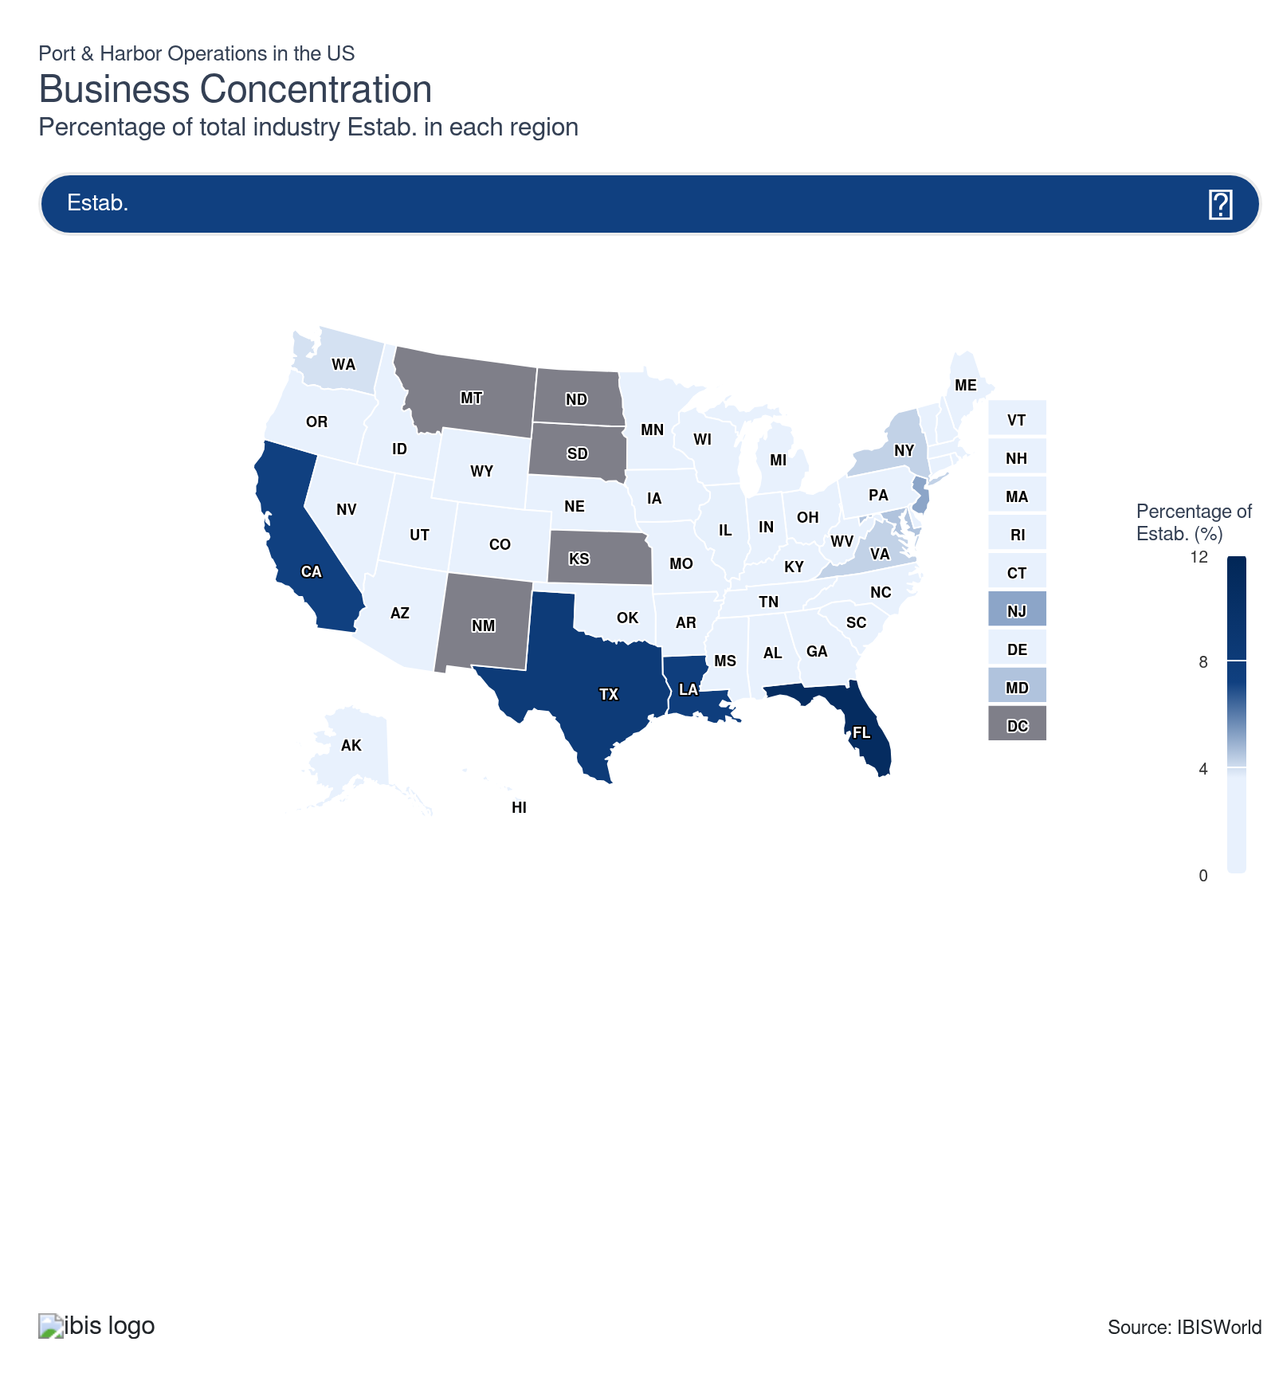
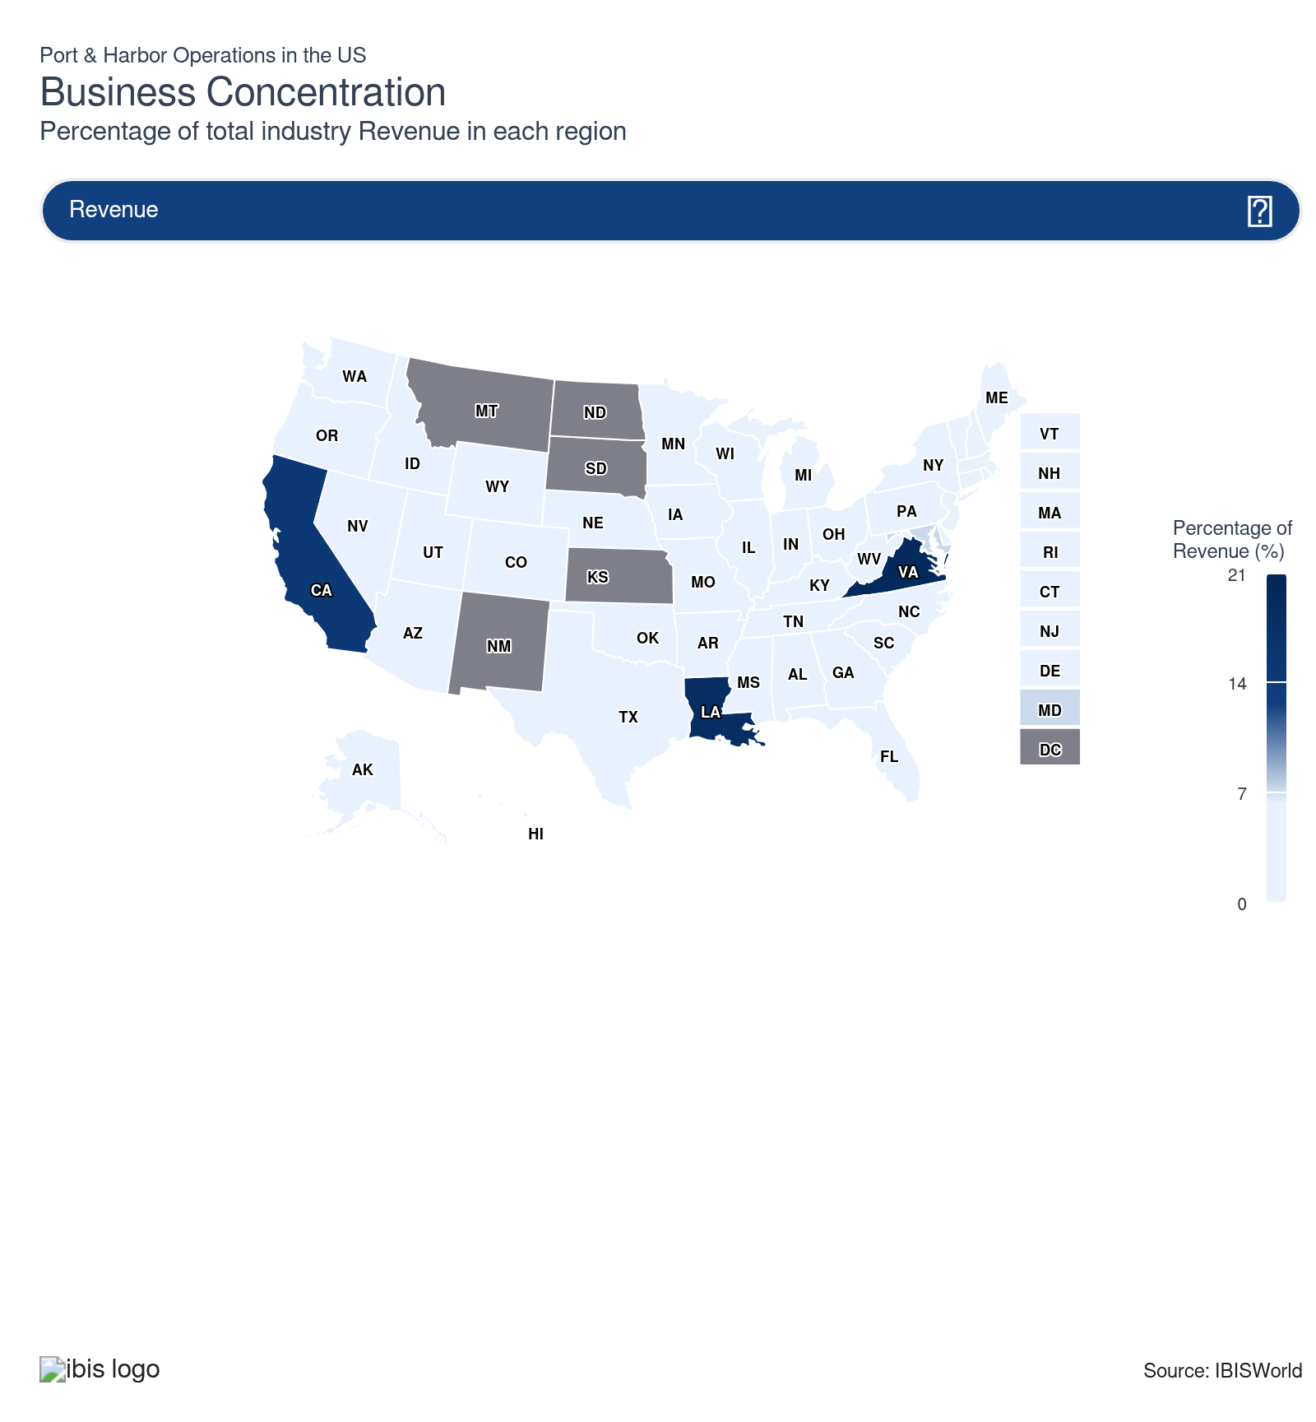
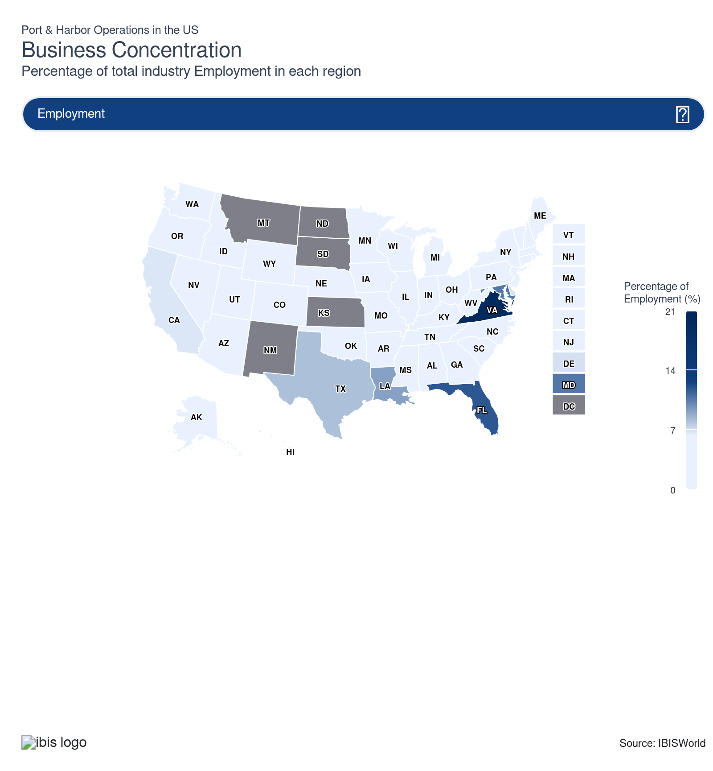
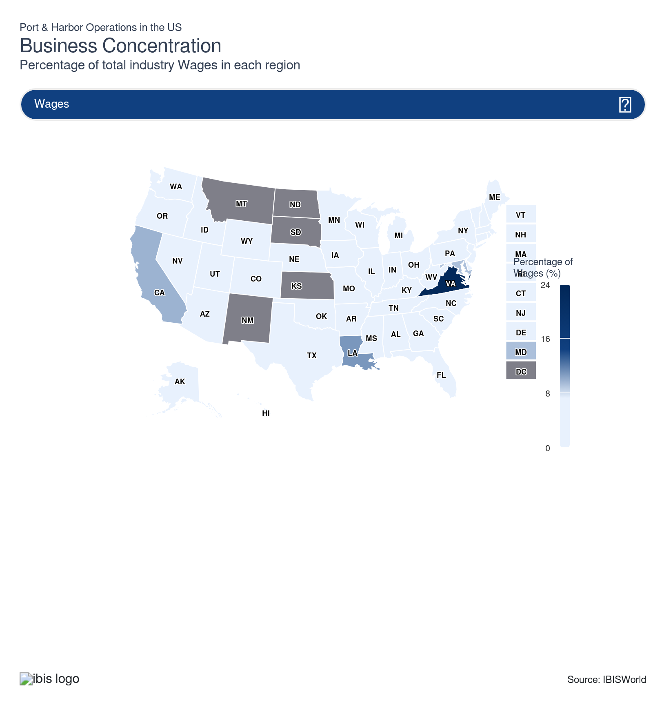
State | Estab.  Units | Estab.  % | Revenue  $m | Revenue  % | Wages  $m | Wages  % | Employment  Units | Employment  % | Population  %
Virginia | 14 | 4.2 | 1,184.2 | 19.7 | 280.7 | 23.0 | 2,963 | 19.7 | 2.6
Florida | 36 | 10.9 | 237.6 | 3.9 | 81.9 | 6.7 | 1,770 | 11.8 | 7.0
Louisiana | 25 | 7.6 | 1,109.0 | 18.4 | 132.8 | 10.9 | 1,377 | 9.2 | 1.3
Texas | 27 | 8.2 | 255.5 | 4.2 | 75.3 | 6.2 | 1,211 | 8.0 | 9.4
California | 24 | 7.3 | 894.1 | 14.8 | 118.9 | 9.7 | 1,004 | 6.7 | 11.5
Maryland | 15 | 4.5 | 430.9 | 7.2 | 112.2 | 9.2 | 1,603 | 10.7 | 1.8
New Jersey | 17 | 5.1 | 360.6 | 6.0 | 77.7 | 6.4 | 621 | 4.1 | 2.8
Delaware | 3 | 0.9 | 160.2 | 2.7 | 60.9 | 5.0 | 1,032 | 6.9 | 0.3
Washington | 13 | 3.9 | 252.4 | 4.2 | 31.2 | 2.6 | 271 | 1.8 | 2.3
New York | 14 | 4.2 | 193.9 | 3.2 | 46.9 | 3.8 | 422 | 2.8 | 5.8
Illinois | 12 | 3.6 | 101.6 | 1.7 | 25.9 | 2.1 | 298 | 2.0 | 3.7
Arkansas | 6 | 1.8 | 111.1 | 1.8 | 18.6 | 1.5 | 299 | 2.0 | 0.9
Alaska | 11 | 3.3 | 81.3 | 1.4 | 6.4 | 0.5 | 118 | 0.8 | 0.2
Ohio | 10 | 3.0 | 60.8 | 1.0 | 14.5 | 1.2 | 186 | 1.2 | 3.5
Pennsylvania | 8 | 2.4 | 36.8 | 0.6 | 14.0 | 1.1 | 205 | 1.4 | 3.8
Tennessee | 7 | 2.1 | 73.8 | 1.2 | 14.4 | 1.2 | 224 | 1.5 | 2.1
Alabama | 7 | 2.1 | 40.7 | 0.7 | 9.4 | 0.8 | 137 | 0.9 | 1.5
Kentucky | 7 | 2.1 | 30.3 | 0.5 | 6.3 | 0.5 | 80 | 0.5 | 1.3
Georgia | 6 | 1.8 | 51.9 | 0.9 | 8.5 | 0.7 | 190 | 1.3 | 3.3
Connecticut | 6 | 1.8 | 39.6 | 0.7 | 13.7 | 1.1 | 104 | 0.7 | 1.1
Michigan | 6 | 1.8 | 5.4 | 0.1 | 3.9 | 0.3 | 78 | 0.5 | 3.0
North Carolina | 4 | 1.2 | 18.7 | 0.3 | 9.6 | 0.8 | 144 | 1.0 | 3.3
Rhode Island | 3 | 0.9 | 33.5 | 0.6 | 2.5 | 0.2 | 35 | 0.2 | 0.3
Missouri | 5 | 1.5 | 23.9 | 0.4 | 6.9 | 0.6 | 111 | 0.7 | 1.8
Indiana | 5 | 1.5 | 20.3 | 0.3 | 3.1 | 0.3 | 45 | 0.3 | 2.0
Minnesota | 5 | 1.5 | 4.9 | 0.1 | 1.3 | 0.1 | 18 | 0.1 | 1.7
South Carolina | 3 | 0.9 | 25.5 | 0.4 | 4.3 | 0.4 | 71 | 0.5 | 1.6
Mississippi | 3 | 0.9 | 15.7 | 0.3 | 5.4 | 0.4 | 95 | 0.6 | 0.9
Wisconsin | 4 | 1.2 | 23.6 | 0.4 | 2.3 | 0.2 | 47 | 0.3 | 1.7
Massachusetts | 4 | 1.2 | 17.0 | 0.3 | 3.0 | 0.2 | 78 | 0.5 | 2.1
West Virginia | 4 | 1.2 | 10.0 | 0.2 | 1.7 | 0.1 | 31 | 0.2 | 0.5
Arizona | 4 | 1.2 | 14.6 | 0.2 | 4.2 | 0.3 | 34 | 0.2 | 2.2
Oregon | 4 | 1.2 | 6.4 | 0.1 | 3.0 | 0.2 | 26 | 0.2 | 1.2
Oklahoma | 2 | 0.6 | 8.6 | 0.1 | 2.2 | 0.2 | 50 | 0.3 | 1.2
Iowa | 3 | 0.9 | 7.2 | 0.1 | 0.7 | 0.1 | 47 | 0.3 | 0.9
Maine | 3 | 0.9 | 2.3 | 0.0 | 0.6 | 0.0 | 13 | 0.1 | 0.4
New Hampshire | 2 | 0.6 | 4.0 | 0.1 | 2.0 | 0.2 | 27 | 0.2 | 0.4
Idaho | 2 | 0.6 | 5.0 | 0.1 | 1.0 | 0.1 | 25 | 0.2 | 0.6
Hawaii | 2 | 0.6 | 2.9 | 0.0 | 1.6 | 0.1 | 23 | 0.2 | 0.4
Vermont | 2 | 0.6 | 2.4 | 0.0 | 1.0 | 0.1 | 20 | 0.1 | 0.2
Nebraska | 2 | 0.6 | 3.7 | 0.1 | 0.8 | 0.1 | 16 | 0.1 | 0.6
Colorado | 2 | 0.6 | 4.8 | 0.1 | 1.2 | 0.1 | 17 | 0.1 | 1.8
Wyoming | 2 | 0.6 | 1.7 | 0.0 | 0.3 | 0.0 | 9 | 0.1 | 0.2
Utah | 2 | 0.6 | 4.5 | 0.1 | 1.0 | 0.1 | 18 | 0.1 | 1.0
Nevada | 2 | 0.6 | 4.5 | 0.1 | 0.9 | 0.1 | 16 | 0.1 | 1.0

Where are industry businesses located?

Affordable land and deep rail access make the Southeast an important region
- The Southeast offers shippers alternatives to congested, costly coastal gateways. Mild year-round weather eliminated seasonal disruptions in Northern ports. Lower land and labor costs also gave providers more room to expand logistics infrastructure without the capital pressure that burdens Northeast terminals. Rail and highway connectivity reached deep into Southeastern and Midwestern inland markets. This made the region a natural distribution hub for goods arriving from Latin American and Asian trade lanes.
- Private and state investment is accelerating the region's lead. Major container terminal expansions currently underway in Savannah represent the most aggressive berth-addition program at any US port. Inland port development is extending the region's reach further into fast-growing Southern markets. Florida's ports serve as the dominant North American cruise embarkation corridor. They act as the primary gateway for Caribbean and Latin American trade flows. These trade routes have remained largely insulated from the tariff disruptions affecting trans-Pacific routes.
- The Southeast's resilience to labor disputes and its growing cold-storage capacity continue to draw discretionary cargo away from competitors. Shippers in the Southeast also permanently diversified supply chains away from China-heavy sourcing. Ports benefited from this because they are also geographically and logistically positioned to serve Latin American corridors that tariffs have left largely intact.

Bulk cargo stability positions Great Lakes ports to generate more revenue through 2026
- Great Lakes ports like Chicago, Cleveland and Detroit provide low-cost access to inland manufacturing and agriculture. They benefit from proximity to the Midwest’s manufacturing sector and direct rail connections. Coal, iron ore, cement, grain and limestone are commonly transported in the region via cargo ships. This positioning insulates the region from some of the volatility hitting container-dependent ports. Bulk commodity flows tend to be driven by industrial production events rather than consumer spending cycles or tariff policy shifts.
- In early February 2026, the American Great Lakes Ports Association (AGLPA) and the Great Lakes St. Lawrence Seaway Development Corporation (GLS) launched a study to identify untapped freight connections between Great Lakes vessels and inland river barges. This strategy is likely to reduce highway congestion, lower emissions and open entirely new cargo corridors. If successful, this connectivity push could meaningfully expand the region's revenue. Greater connectivity could also reduce reliance on seasonal bulk movements. This would attract new shippers and cargo types that currently bypass the region entirely.
- The region's fundamental constraint remains its weather-driven seasonality and the physical draft limitations of the St. Lawrence Seaway. This prevents the largest modern container vessels from transiting effectively. It also caps diversification into containerized trade. Until federal dredging investment and winter navigation infrastructure advance materially, Great Lakes ports will likely remain essential to bulk-dependent Midwest industries. They could remain limited in their ability to compete for the higher-profit container and breakbulk segments where coastal rivals continue to pull ahead.

Long-term terminal leases reshape the Northeast's competitive position
- The Northeast has responded to intensifying competition from lower-cost Southeast rivals by leveraging its irreplaceable access to the US's densest consumer market as a bargaining tool with global shipping lines.
- Rather than competing on cost, the Port of New York and New Jersey is extracting greater long-term value from terminal providers through extended lease structures that lock in revenue certainty. Contracts also require tenants to fund infrastructure reinvestment. Global carriers recognize that the Northeast is structurally distinct from any other US gateway. This suggests they will likely compete aggressively for terminal ownership and long-term operating rights.
- This landlord-driven model provides revenue stability that insulates the port from short-term cargo fluctuations, but it also concentrates terminal ownership among a small number of global shipping lines. Priorities may not always align with the port authority's broader regional economic mission. High land and labor costs also remain persistent structural headwinds. This keeps the Northeast's cost-per-move higher than Southeast competitors'.
- Deep-water infrastructure, dense urban consumption and premium carrier service frequency support revenue from the region. Shippers of time-sensitive, high-value cargo will likely continue to depend on Northeast ports. Flood- and storm-resilience investments could also attract more shippers. Sustained tenant pressure for infrastructure upgrades will likely be the defining variable in whether the Northeast can maintain its premium positioning as Southeast capacity continues to expand at a record pace.

Front-loading masked West Coast strength in 2025
- US retailers and manufacturers stocked up on inventory ahead of tariffs in early 2025. This produced record annual volumes that masked a sharp deterioration in underlying trade conditions. Once tariffs took hold, the concentration of West Coast trade on China-origin routes became a structural liability rather than a historical strength. Chinese manufacturers began rerouting production to Southeast Asia. US shippers also diversified sourcing away from direct China imports.
- The automation investments, sustainable infrastructure buildout and berth expansions that define the West Coast's long-term competitiveness strategy were all sized for continued volume growth. This made the current period of demand contraction a direct risk to profit. Fixed costs built for higher throughput became harder to justify when cargo flows are redirected or suppressed. The region's focus on trans-Pacific lanes makes it uniquely sensitive to US-China trade policy, whereas the Southeast's more diversified origin mix is not. That sensitivity is unlikely to diminish regardless of short-term tariff negotiations.
- The West Coast retains structural advantages that no Southeast rival can quickly replicate. It has the largest concentration of trans-Pacific carrier services, the most advanced automation ecosystems in the country and established carrier relationships built over decades. A meaningful US-China trade framework that reduces tariff pressure would rapidly restore volume momentum through 2026.

Record energy export volumes support revenue from the Southwest
- The Southwest's competitive identity is built on an energy infrastructure advantage that has taken decades to assemble. The Southwest benefits from proximity to the largest concentration of petrochemical and crude oil production in the US. It also has deepwater channel access and competitive land and labor costs. This gives Texas ports a structural cost advantage in energy-related wharfage, storage and vessel handling.
- This is supported by every new LNG terminal and pipeline connection that comes online. The current administration's aggressive posture on expanding hydrocarbon exports aligns directly with the Southwest's core competency. This directs federal infrastructure spending toward the very port corridors already positioned to handle growth.
- That federal investment could produce tangible capacity additions through 2026. Completed channel deepening projects are enabling larger crude tankers to load and depart without tide restrictions in the Southwest. Newly approved LNG export capacity expansions are extending the region's role as the US's primary swing supplier to global energy markets. This position gained urgency in 2026 because geopolitical disruptions in competing LNG export regions forced buyers to rely more heavily on Gulf Coast supply reliability.
- Hurricane risk and drought-driven water level variability remain the region's most significant operational threats. These natural disasters disrupted energy shipment schedules precisely when global buyers were most dependent on US supply. Diversification into agricultural exports, petrochemicals and LNG bunkering services already broadens the revenue base beyond crude and refined products. This provides a partial buffer against energy price cycles. Ports that invest in energy capacity expansion will likely support the Southwest's dominant export position.

How do businesses use location to their advantage?
Operate in a location that is close to key markets
Proximity to key markets reduces transportation time and costs. This increases the port's attractiveness to shippers that rely on swift, cost-effective access to their target consumer base.
Operate in a location with appropriate water supply, soil type and climate
Optimal natural conditions are essential for the stability and operation of port infrastructure. A reliable water supply ensures smooth shipping operations. Providers who benefit from suitable soil and climate will likely spend less on port equipment and maintenance.

6. Competitive Forces
https://my.ibisworld.com/us/en/industry/48831/competitive-forces

Key Takeaways
- Concentration dropped because volume spread across Southeast and Gulf Coast ports. This reduced the dominance of legacy West Coast and Northeast gateways. The entry of private terminals deepened fragmentation through the beginning of 2026.
- Buyer power increased for discretionary cargo categories because shippers secured fee concessions and rerouted inventory. However, core wharfage fees remain publicly regulated. This limited buyer power where port service providers hold structural geographic advantages.
- Cloud and technology supplier dependency is increasing pricing leverage against port service providers. The proposed United States Trade Representative fees on Chinese-built vessels contribute to upstream cost pressure from multiple supplier directions.

Concentration
Moderate
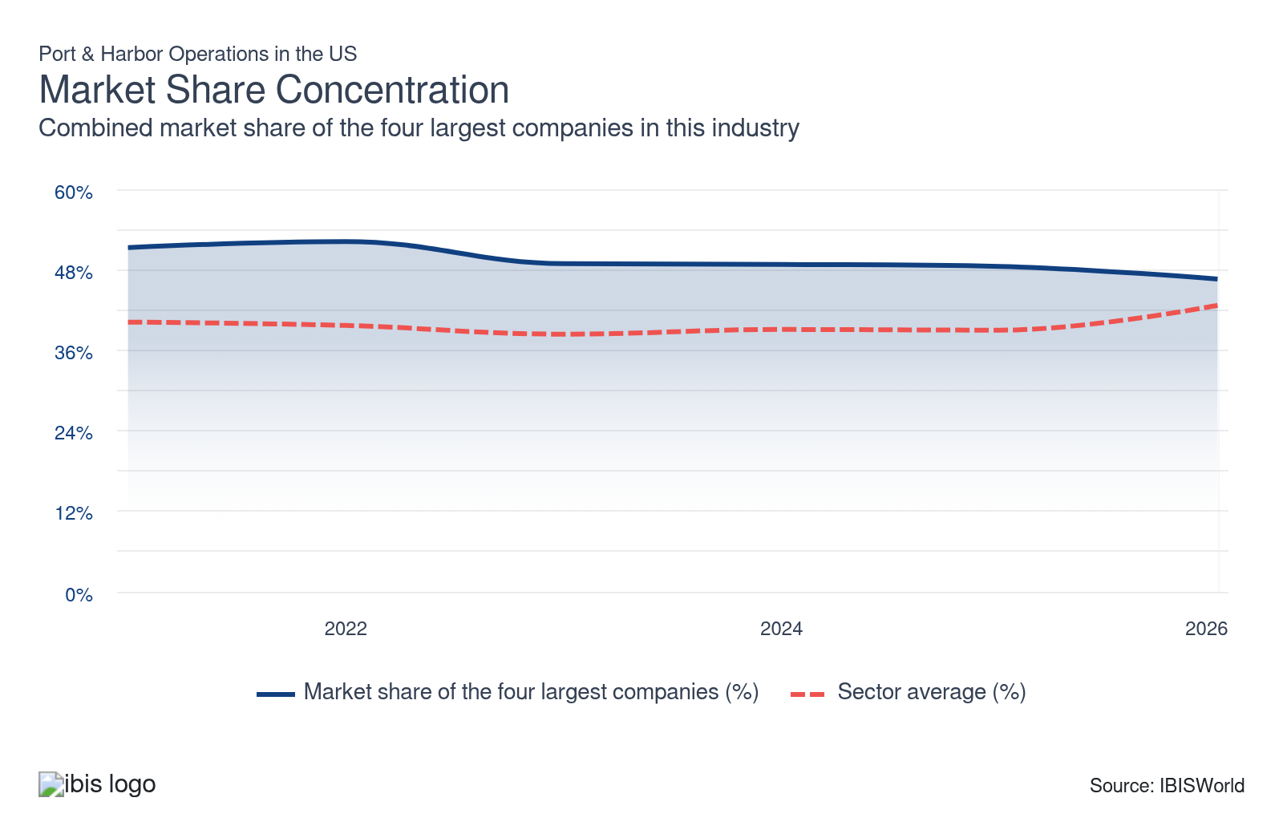

What impacts the industry’s market share concentration?

Rise in e-commerce leads to some port fragmentation
- Major ports in the US located along the coast facilitate most international trade. Ports in Texas, California, New York and New Jersey are vital in receiving shipments and exporting goods worldwide. International trade is increasingly concentrated among a few key ports that handle the bulk of shipments.
- Many ports and harbors participate in the distribution process to alleviate congestion and improve the distribution efficiency of vast amounts of cargo. With the rise of e-commerce, smaller ports can compete more effectively with larger service providers.

Inland ports facilitate domestic trade and alleviate congestion from main ports
- Small and medium-sized ports, including dry land ports, are capturing market share from the top players. With advancements in logistics technology, many port operators are developing infrastructure focusing on distribution to alleviate pressure from the supply chain.
- A smaller physical footprint lowers start-up costs for new entrants. By specializing in just one segment of the distribution chain or handling a specific cargo type, some ports reduced their legal and capital spending. This made entry less expensive. Specialization has placed downward pressure on market concentration over the last five years through 2026.

Cargo rerouting reduced the dominance of legacy gateway ports
- Over the past five years through 2026, concentration dropped because volume growth spread across a broader set of ports. The Southeast led this redistribution. Port of Savannah cargo volume surged in 2025 and 2026. This made it the fastest-growing major container gateway on the East Coast. At the same time, Charleston posted its third-best year on record in 2025. Tariff-driven front-loading and subsequent rerouting further fragmented volume. Shippers diversified away from West Coast bottlenecks and China-heavy trans-Pacific lanes. They actively found alternatives with lower congestion risk and more stable labor relations.
- The entry of new private terminals and the expansion of regional inland ports deepened this fragmentation. Global shipping lines secured terminal ownership stakes at multiple gateways simultaneously. This led to a redistribution of volumes across the network. It also led to a drop in concentration from the pre-pandemic competitive structure. Southeast and Gulf Coast ports continue adding berth capacity and inland connectivity through 2026. The gap between the largest and mid-tier port providers is likely to narrow further through 2026.

How do successful businesses handle concentration?
Leverage the operation's size, type and efficiency
Efficient port operations with large capacity and specialized facilities attract more business, handle diverse cargo types and ensure quick turnaround times. This is crucial in a concentrated market.
Develop strong working relationships with subcontractors
Strong relationships with subcontractors and logistics firms ensure efficient port operations and timely cargo handling. This helps to maintain reliability and customer satisfaction in a competitive environment.

Barriers to Entry
High | Steady

What challenges do potential industry entrants face?

Legal
- US ports must navigate a maze of federal, state and local regulations, ranging from the Jones Act and Clean Water Act to local zoning restrictions and union labor laws. Environmental permits for dredging and emissions, along with strict customs and safety rules, add complexity. These legal requirements often slow expansion, increase operational costs and mandate recurring investments in compliance and reporting. This raises the bar for both entrants and existing ports.

Start-up Costs
- Launching or expanding a port requires a significant up-front investment in land acquisition or leasing, terminal, warehouse and docking facility construction, environmental assessments, equipment purchases (such as cranes and yard vehicles) and IT systems. These capital-intensive start-up costs frequently reach hundreds of millions, typically requiring public-private partnerships, municipal bonds and federal grants. The scale of investment needed creates substantial barriers to entry.

Differentiation
- Leading ports stand out by investing in advanced automation, AI-powered terminal operating systems and green initiatives, such as electrified cargo handling and shore power. Differentiation also comes through specialty service offerings, like cruise terminals, cold storage or integrated intermodal logistics. Superior customer experiences, including real-time tracking and fast vessel turnaround, can also distinguish operators. These factors attract higher cargo volumes and long-term contracts, helping ports maintain a commercial advantage even in competitive corridors.

Capital Expenses
- Port competitiveness depends on ongoing investment in projects such as dock expansion, dredging and the installation of modern equipment (cranes, straddle carriers, cybersecurity systems, renewable energy upgrades). These large-scale investments are depreciated over decades and are commonly financed by public grants, municipal or authority-issued bonds and retained earnings. The need for ongoing capital renewal shapes budgeting and partnership choices for all major US ports.

How can potential entrants overcome barriers to entry?
Ensure proper licensing
Navigating complex maritime regulations requires securing the proper licenses. Compliance with legal frameworks fosters smoother operations and mitigates legal risks for port and harbor businesses.
Secure distribution channels
Establishing reliable distribution channels is crucial for efficient cargo movement. Solid partnerships with logistics firms enhance the capacity to handle large volumes. This promotes operational efficiency and competitiveness.

Substitutes
Moderate | Increasing

What are substitutes for industry services?

Rail transportation
- Tight trucking capacity in early 2026 enabled major railroads to recapture freight from road carriers. BNSF and CSX launched a new coast-to-coast domestic intermodal service. This connected Southern California with Jacksonville and Charlotte. These corridors directly compete with port-dependent drayage networks. The proposed Union Pacific and Norfolk Southern merger, under review by the Surface Transportation Board as of April 2026, would create the first true coast-to-coast single-line rail network in the US. This could reshape how shippers route domestic freight and reduce their reliance on specific coastal ports for inland distribution.
- Despite this momentum, intermodal rail volumes dropped modestly through 2025. They were weighed down by softening consumer demand and the same tariff-driven import contraction hitting ports. Rail remains structurally complementary to ports rather than a substitute for them. The vast majority of containerized goods still arrive by vessel and are transferred to rail for inland transport. This makes port infrastructure the indispensable first link in the chain. For trans-oceanic trade, no domestic rail network can circumvent the need for deep-water port access.

Air transportation
- Air cargo demand climbed through 2025 because trade disruptions and supply chain uncertainty prompted shippers of electronics, pharmaceuticals, and high-value consumer goods to shift toward the speed and reliability of air over the scheduling unpredictability of ocean shipping.
- E-commerce will likely account for a larger share of global air freight volumes. Platforms like Amazon, Temu and Shein have built cross-border logistics networks that route consumer goods directly by air to bypass ocean freight timelines. The removal of the de minimis tariff exemption for Chinese e-commerce shipments in 2025 created a significant headwind.
- Air freight will likely continue capturing share in niche, high-profit cargo categories where speed justifies the cost premium. Still, it poses no structural threat to port revenue for the bulk of traded goods. Aircraft will also likely continue to face capacity constraints and high costs. This keeps air transportation from overtaking ports over the next five years through 2031.

How do successful businesses compete with substitutes?
Secure economies of scale
Economies of scale lower operational costs, making it harder for other logistics providers to compete in price. Large port operations can invest in better infrastructure and services, providing greater value to shipping companies.
Develop strong technical product knowledge
Port operators' in-depth technical knowledge allows them to offer specialized services and handle complex shipping requirements, making them indispensable. This expertise can set them apart from potential substitutes that lack similar capabilities.

Buyer & Supplier Power
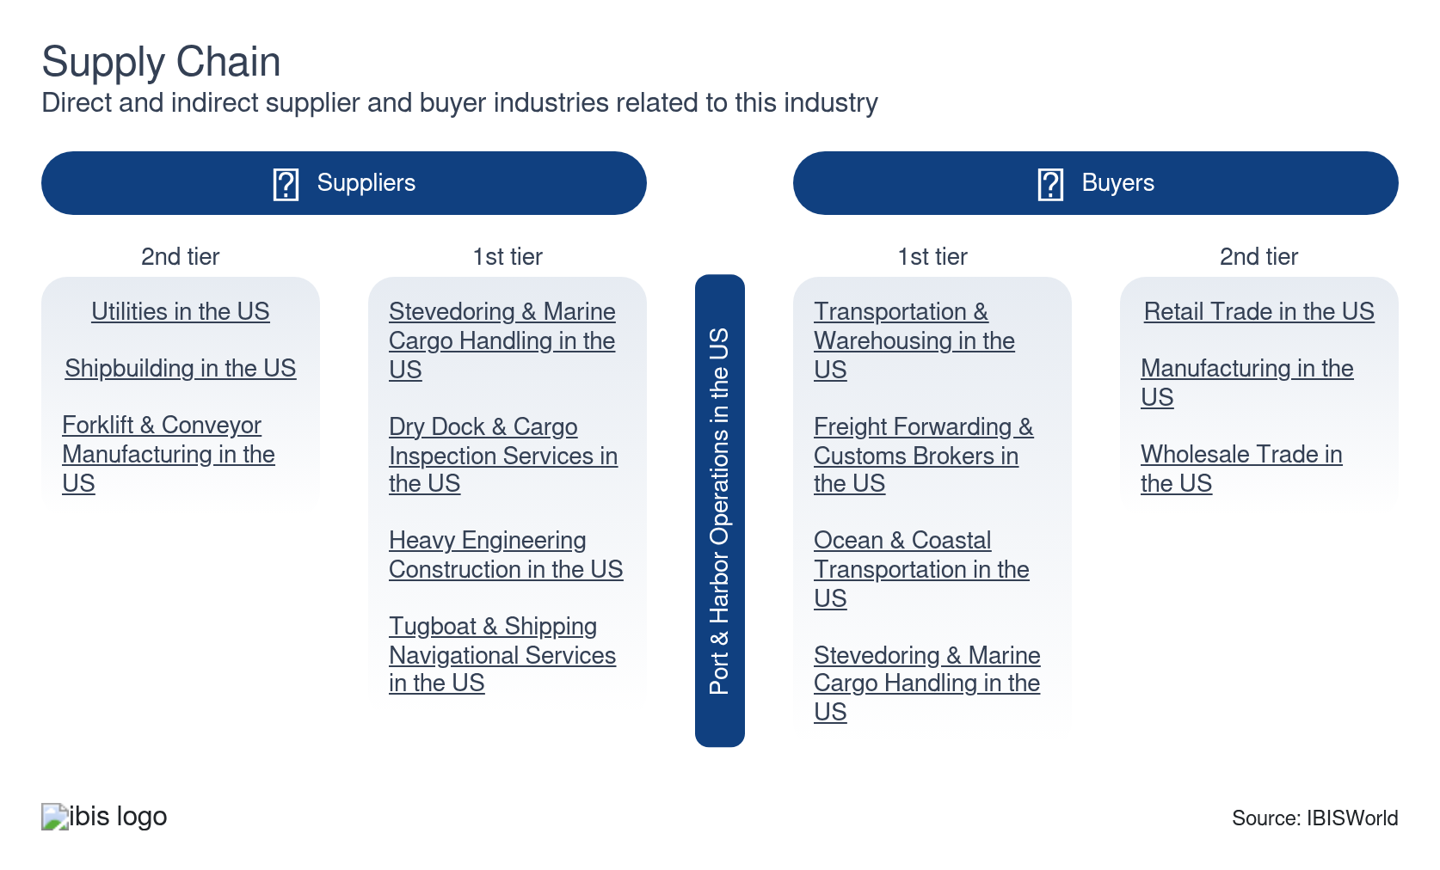

What power do buyers and suppliers have over the industry?

Buyers: Tariff pressure and rerouting options give shippers leverage
Moderate | Steady
- Tariff-driven volume uncertainty reduced cargo flows through 2025. Shippers gained meaningful leverage in fee negotiations, particularly on discretionary charges like terminal handling, congestion surcharges and demurrage. High-volume contract customers increasingly secured fee caps, extended free-time windows and reduced daily rates in exchange for volume commitments.
- The Southeast's rapid capacity expansion gave shippers a credible threat of rerouting away from congested West Coast and Northeast terminals. The proposed Union Pacific–Norfolk Southern merger could create a further alternative by enabling coast-to-coast single-line rail routing that bypasses specific coastal gateways entirely.
- Buyer power remains structurally constrained by geography and public regulation, however. Core wharfage fees and security charges are tariff-based and set or approved by public port authorities rather than negotiated privately. This leaves shippers with limited ability to contest the foundational cost of port access. Buyer leverage will likely remain strongest for discretionary cargo and weakest precisely where port service providers hold the most structural advantage.

Suppliers: Cloud dependency and Chinese vessel fee proposals are shifting supplier power
Moderate | Increasing
- Cloud infrastructure providers like AWS and Azure are gaining pricing leverage over port service providers as digital logistics platforms become more common in 2026. Hardware cost increases flow through provider pricing structures. Ports that have committed to multi-year digital transformation programs face limited ability to renegotiate or switch platforms without significant operational disruption. This dependency mirrors the dynamic in stevedoring and marine cargo handling, where specialized labor and equipment create switching costs. This gives suppliers sustained pricing power.
- The United States Trade Representative's 2025 proposal to impose port fees on Chinese-built or Chinese-operated vessels is restructuring the cost dynamics between ports and their upstream shipping line suppliers. Major carriers operating Chinese-built fleets began exploring vessel swaps and alliance reshuffling in response. However, with the global orderbook dominated by Chinese-built vessels, full substitution is likely impossible in the near term. This leaves ports caught between absorbing carrier surcharges passed downstream or risking losing call volumes to competing gateways.

How do successful businesses manage buyer & supplier power?
Develop a strong market profile
Establishing a robust market presence enables ports to attract key shipping and logistics providers. This reduces dependency on any single supplier or buyer and helps to balance power dynamics.
Secure access to high-quality inputs
Ensuring high-quality infrastructure and services, such as advanced cranes and efficient cargo handling, attracts major clients and suppliers. This minimizes supplier power and buyer volatility risk. It also fosters long-term partnerships and operational stability.

7. Companies
https://my.ibisworld.com/us/en/industry/48831/companies

Key Takeaways
- MSC's proposed acquisition of CK Hutchison's global terminal portfolio suggests aggressive vertical integration by global carriers. If completed, it could reshape the competitive dynamics for independent port authorities.
- The Port of New York and New Jersey's 33-year APM Terminals lease and CMA CGM's terminal ownership stake reflect a broader shift toward carrier-owned infrastructure. Port authorities extract larger revenue shares from these deals.
- Smaller single-port service providers face risk from trade volatility and tariff-driven volume swings. Larger ports with diversified cargo and service lines are more resilient. Consolidation could increase in 2026 if providers seek scale to manage fixed costs.

Market Share
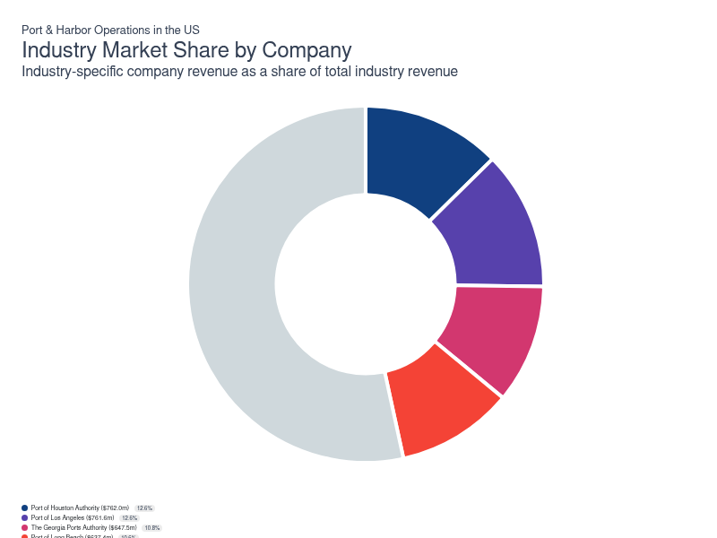
Chart displays current year only in the PDF version of this report. You can view and download chart for all other years associated with this industry on my.ibisworld.com.

Companies
Company | Market Share (%)  2026 | Revenue ($m)  2026 | Profit ($m)  2026 | Profit Margin (%)  2026
Port of Houston Authority | 12.7 | 762.0 | 247.7 | 32.5
Port of Los Angeles | 12.6 | 761.6 | 430.2 | 56.5
The Georgia Ports Authority | 10.8 | 647.5 | 111.6 | 17.2
Port of Long Beach | 10.6 | 637.4 | 227.2 | 35.6
The Port Authority Of New York & New Jersey | 5.5 | 330.1 | 70.2 | 21.3
The Northwest Seaport Alliance | 3.4 | 203.9 | 96.1 | 47.1

Port of Houston Authority
Port of Houston Authority
Company Details
Company Details
Industry Specific Revenue (2026) | $762.0m
Industry Profit (2026) | $247.7m
Company Employees (2026) | 56,113
Market Share (2026) | 12.7%

Description
Description
Port of Houston Authority is a private company with an estimated 56,113 employees. In the US, the company has a notable market share in at least one industry: Port & Harbor Operations, where they account for an estimated 7.7% of total industry revenue and are considered an All Star because they display stronger market share, profit and revenue growth compared to their peers.

Brands and Trading Names
Brands and Trading Names
- Port Houston

Company’s Industry Revenue, Market Share, and Profit Margin Over Time
Company’s Industry Revenue, Market Share, and Profit Margin Over Time
Year | Industry Revenue ($ million) | Market Share (%) | Profit Margin (%)
2020 | 451 | 11.8 | 27.2
2021 | 569 | 13.4 | 38.2
2022 | 719 | 14.1 | 43.1
2023 | 685 | 12.8 | 37.5
2024 | 751 | 13.4 | 33.6
2025 | 762 | 13.2 | 32.5
2026 | 762 | 12.7 | 32.5

What's impacting Port of Houston Authority's performance?

Port Houston container volume continues to increase
- On March 28, 2022 the Port of Houston Authority (Port Houston) reported that container volume is up 37.0% compared to the same month in 2021. The company stated that this is the largest February Port Houston has seen in terms of containers. Additionally, Port Authority stated that in response to the strong growth they are accelerating projects at container terminals. Specifically, the company will open additional gates at the Barbours Cut Container Terminal.

Port Houston reports update to COVID-19 procedures
- Port of Houston Authority (Port Houston) posted their updates regarding the COVID-19 (coronavirus) pandemic. Port Houston is a part of critical infrastructure industry as identified by the Department of Homeland Security and therefore have always been permitted to remain operational. Port Houston is operating at normal business hours and has implemented extensive deep cleaning routines and sanitization of terminals as well as following social distancing procedures.

Port of Houston announces growth in early 2022
- On March 1, 2022, Port Houston Authority (Port Houston) announced that they saw 19.0% growth in cargo tonnage for January 2022. For comparison, 2021 experienced a 15.0% increase in cargo growth. Additionally, Port Houston announced the re-appointment of three port commissioners. At the monthly meeting, Port Chairman Ric Campo recognized the re-appointment of Commissioner Stephen DonCarlos, Cheryl Creuzot and Commissioner Wendy Montoya Coonan.
Port of Los Angeles
Port of Los Angeles
Company Details
Company Details
Industry Specific Revenue (2026) | $761.6m
Industry Profit (2026) | $430.2m
Company Employees (2026) | 1,000
Market Share (2026) | 12.6%

Description
Description
Port of Los Angeles is a private company with an estimated 1,000 employees. In the US, the company has a notable market share in at least one industry: Port & Harbor Operations, where they account for an estimated 13.0% of total industry revenue and are considered an All Star because they display stronger market share, profit and revenue growth compared to their peers.

Company’s Industry Revenue, Market Share, and Profit Margin Over Time
Company’s Industry Revenue, Market Share, and Profit Margin Over Time
Year | Industry Revenue ($ million) | Market Share (%) | Profit Margin (%)
2020 | 468 | 12.2 | 7.6
2021 | 570 | 13.4 | 25.0
2022 | 628 | 12.3 | 36.1
2023 | 656 | 12.3 | 24.7
2024 | 707 | 12.6 | 37.4
2025 | 762 | 13.1 | 56.5
2026 | 762 | 12.6 | 56.5

What's impacting Port of Los Angeles's performance?

Public, environmental and security investments support future readiness amid uncertainty
- Significant investments continue in waterfront redevelopment, environmental enhancements and security improvements, ranging from shore power and air quality upgrades to constructing a new cyber resilience center and advanced port policing infrastructure. Despite recent declines in some categories of royalty and parking revenues, programs like the Clean Truck Fund have helped offset losses, while public access and ESG spending bolster community and customer support. These improvements aim to position the port for long-term sustainability and compliance, strengthening its appeal to shippers and stakeholders as the industry’s regulatory and competitive landscape evolves.

Infrastructure investment and modernization keep the Port of Los Angeles resilient but space and expansion limits persist
- The Port of Los Angeles prioritizes long-term competitiveness, dedicating over $250.0 million annually to capital improvements such as terminal upgrades, expanded rail corridors, sustainability enhancements and security infrastructure. These projects have improved operational efficiency, advanced environmental goals and prepared the port for rising commercial and regulatory demands. However, with high terminal occupancy and limited land available for expansion, the port faces ongoing constraints in accommodating additional traffic, making resource allocation and long-term leasing agreements with customers even more critical for maintaining its leading market position.

The Port Authority of Los Angeles announces plan to prioritize US dairy product exports
- On February 24, 2022, The International Dairy Foods Association (IDFA) and the Port of Los Angeles announced that the groups are working together to prioritize exports of US dairy products despite supply chain issues. At the time of writing, steps have already been taken to prioritize US dairy products. This includes additional space and equipment allocated to an IDFA member for 120 containers per week with the capability to increase to 300 containers per week.

Port of Los Angeles introduces new features to Port Optimizer
- On February 28, 2022 the Port of Los Angeles introduced new features to its Port Optimizer. The Port Optimizer is the America’s first and only port community system that permits shippers, cargo owners, terminal operator and others to better predict and plan cargo at the port. According to the Executive Director, with the enhancements, the Port Optimizer will provide visibility for 70.0% of the import data for the San Pedro Bay port complex.

Shipping services and wharfage fees lead revenue but market pressures weigh on results
- Shipping services, including wharfage, dockage and pilotage fees, remain the backbone of revenue, accounting for nearly three-quarters of all operating income. In fiscal 2024, surging cargo rates and TEU volumes boosted wharfage revenue by $74 million yearly, while rental income from facilities and land provided additional financial stability. Yet, due to ongoing US-China trade tensions, the LA and Long Beach ports saw a 24% drop in container deliveries in May from April 2025, according to port data. There were also multiple ship cancellations and related layoffs. As facility revenues stabilize, the broader environment remains volatile, highlighting the need for diversified revenue streams and cost discipline.
The Georgia Ports Authority
The Georgia Ports Authority
Company Details
Company Details
Industry Specific Revenue (2026) | $647.5m
Industry Profit (2026) | $111.6m
Company Employees (2026) | 1,500
Market Share (2026) | 10.8%

Description
Description
Georgia Ports Authority is a private company with an estimated 1,500 employees. In the US, the company has a notable market share in at least one industry: Port & Harbor Operations, where they account for an estimated 9.5% of total industry revenue and are considered an All Star because they display stronger market share, profit and revenue growth compared to their peers.

Company’s Industry Revenue, Market Share, and Profit Margin Over Time
Company’s Industry Revenue, Market Share, and Profit Margin Over Time
Year | Industry Revenue ($ million) | Market Share (%) | Profit Margin (%)
2020 | 477 | 12.4 | 28.2
2021 | 611 | 14.3 | 35.1
2022 | 833 | 16.4 | 44.6
2023 | 754 | 14.1 | 34.7
2024 | 699 | 12.5 | 24.5
2025 | 647 | 11.2 | 17.2
2026 | 647 | 10.8 | 17.2

What's impacting The Georgia Ports Authority's performance?

GPA announces the completion of the Savannah Harbor deepening
- On March 25, 2022 the Georgia Ports Authority (GPA) with the US Army Corps of Engineers and Georgia Department of Transportation announced the completion of the Savannah Harbor deepening. This project was done to expedite the flow of cargo to and from global destinations by reducing tidal restrictions for mega-ships transiting the Savannah River. GPA states that faster vessel service means that the Port of Savannah can handle more ships each year.

Georgia Ports Authority extends growth trend after record February
- The Georgia Ports Authority (GPA) announced that they will develop 85 additional acres and expand its vehicle processing facilities at the Port of Brunswick. This $538.0 million capacity expansion was approved to meet the growing demand. For example, the Port of Savannah reported that container volume grew nearly 18.0% in February 2022, extending year-over-year increases to 19 consecutive months for the GPA.
Port of Long Beach
Port of Long Beach
Company Details
Company Details
Industry Specific Revenue (2026) | $637.4m
Industry Profit (2026) | $227.2m
Company Employees (2026) | 442
Market Share (2026) | 10.6%

Description
Description
Port of Long Beach is a private company with an estimated 442 employees. In the US, the company has a notable market share in at least one industry: Port & Harbor Operations, where they account for an estimated 7.4% of total industry revenue.

Brands and Trading Names
Brands and Trading Names
- Port of Long Beach

Company’s Industry Revenue, Market Share, and Profit Margin Over Time
Company’s Industry Revenue, Market Share, and Profit Margin Over Time
Year | Industry Revenue ($ million) | Market Share (%) | Profit Margin (%)
2020 | 399 | 10.4 | 26.7
2021 | 435 | 10.2 | 29.2
2022 | 480 | 9.4 | 27.8
2023 | 515 | 9.7 | 31.8
2024 | 573 | 10.2 | 33.7
2025 | 637 | 11.0 | 35.6
2026 | 637 | 10.6 | 35.6

What's impacting Port of Long Beach's performance?

Port of Long Beach hits record highs to kick off the new year
- The Port of Long Beach had a hot start to the new year with its busiest January of all time, due to efforts to move out aging cargo. In January, port operators moved 800,943 twenty-foot equivalent units (TEU), up from 4.8% compared with last year. Furthermore, imports and exports increased 6.9% and 5.9%, respectively, as the economy continues to recover from the effects of the COVID-19 (coronavirus) pandemic.

Make way for the future - Port of Long Beach to demolish iconic bridge
- In February 2022, the Port of Long Beach announced that it would begin the demolition of the Gerald Desmond Bridge starting May 2022. It is expected to be completed in 2023 and will cost the port $59.9 million. The demolition will be integral to the port moving forward, as over the years the bridge became too narrow to keep up with the rise in truck traffic as the port’s cargo volume increased.
The Port Authority Of New York & New Jersey
The Port Authority Of New York & New Jersey
Company Details
Company Details
Industry Specific Revenue (2026) | $330.1m
Industry Profit (2026) | $70.2m
Company Employees (2026) | 8,000
Market Share (2026) | 5.5%

Description
Description
Port Authority Of New York & New Jersey is a private company with an estimated 8,000 employees. In the US, the company has a notable market share in at least two industries: Airport Operations, Port & Harbor Operations and Port & Harbor Operations. Their largest market share is in the Airport Operations industry, where they account for an estimated 22.8% of total industry revenue.

Brands and Trading Names
Brands and Trading Names
- John F. Kennedy (JFK) International Airport
- La Guardia Airport
- Newark International Airport
- Path

Other Industries
Other Industries
- Airport Operations in the US

Company’s Industry Revenue, Market Share, and Profit Margin Over Time
Company’s Industry Revenue, Market Share, and Profit Margin Over Time
Year | Industry Revenue ($ million) | Market Share (%) | Profit Margin (%)
2008 | 181 | 13.0 | 13.0
2009 | 177 | 9.9 | 13.0
2010 | 183 | 9.9 | 13.0
2011 | 198 | 9.9 | 13.0
2012 | 232 | 9.9 | 13.0
2013 | 258 | 9.9 | 13.0
2014 | 271 | 9.9 | 13.0
2015 | 297 | 9.9 | 13.0
2016 | 301 | 9.9 | 13.0
2017 | 296 | 9.2 | 13.9
2018 | 311 | 9.1 | 16.9
2019 | 322 | 8.8 | 14.5
2020 | 328 | 8.6 | 19.1
2021 | 330 | 7.8 | 21.3
2022 | 330 | 6.5 | 21.3
2023 | 330 | 6.2 | 21.3
2024 | 330 | 5.9 | 21.3
2025 | 330 | 5.7 | 21.3
2026 | 330 | 5.5 | 21.3

What's impacting The Port Authority Of New York & New Jersey's performance?

New International Terminal at JFK
- The Governor of New York, Kathy Hochul recently announced a plan to build a new international terminal at JFK. This terminal will have 23 gates and be 2.4 million square feet. The New Terminal One will begin construction in 2022. The first set of gates is planned to open in 2026.

You can view and download company details on my.ibisworld.com.

8. External Environment
https://my.ibisworld.com/us/en/industry/48831/external-environment

Key Takeaways
- Tariff policy is the dominant external driver. Import duties created record import surges in early 2025, followed by volume contractions that exposed port cost structures. Trade-weighted dollar strength supported export headwinds, particularly for agricultural and bulk commodity corridors.
- An International Longshoremen's Association labor contract increased wages across East and Gulf Coast ports through 2030. Automation restrictions embedded in the contract limited providers' ability to offset these costs through technology.
- Liquefied natural gas export growth and regulatory clarification on bunkering are shifting Gulf Coast revenue toward energy-related wharfage. The Energy Information Administration forecasts continued LNG volume growth through 2027, assuming capacity expansion.

External Drivers

What demographic and macroeconomic factors impact the industry?
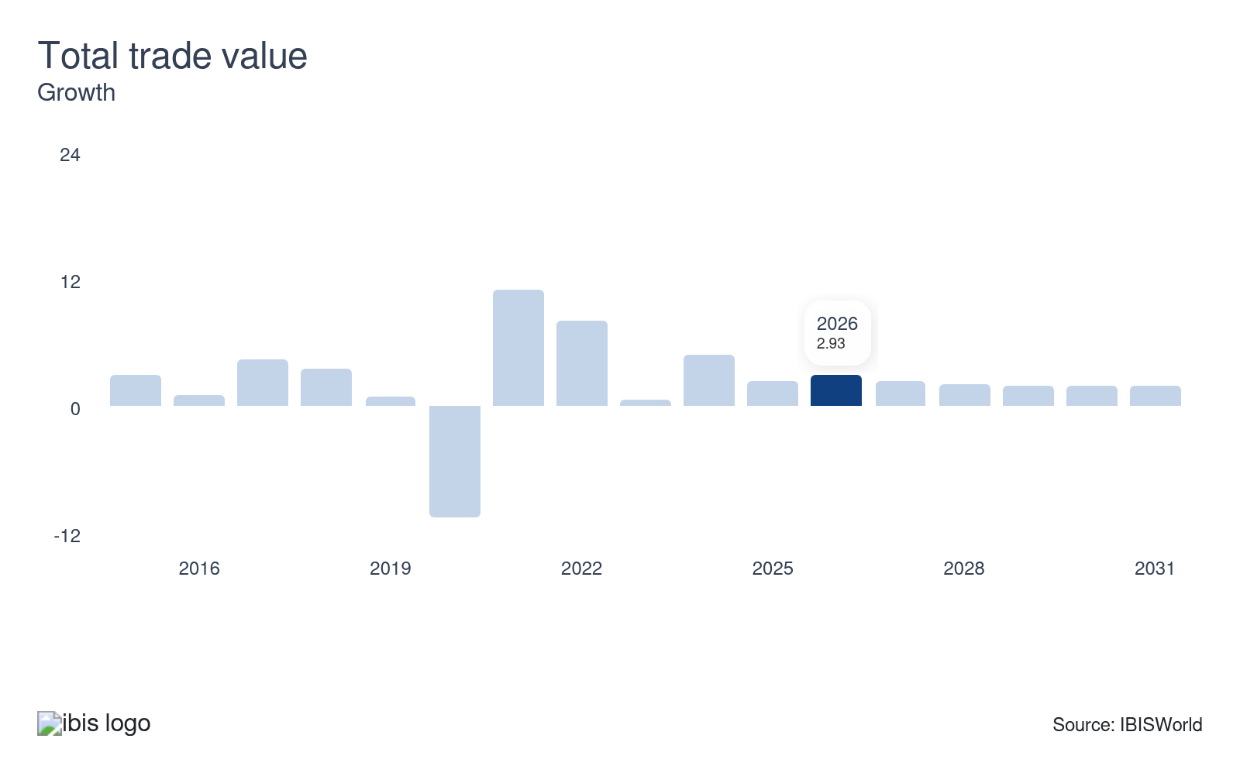
Ports and harbors facilitate the entry and exit of traded goods. If trade activity continues to climb through 2026, demand for port and harbor services will likely increase. Conversely, if trade activity contracts, demand for these services could drop, reducing revenue. With globalization trends persisting, trade value is likely to continue increasing. This creates an opportunity for ports and harbors.
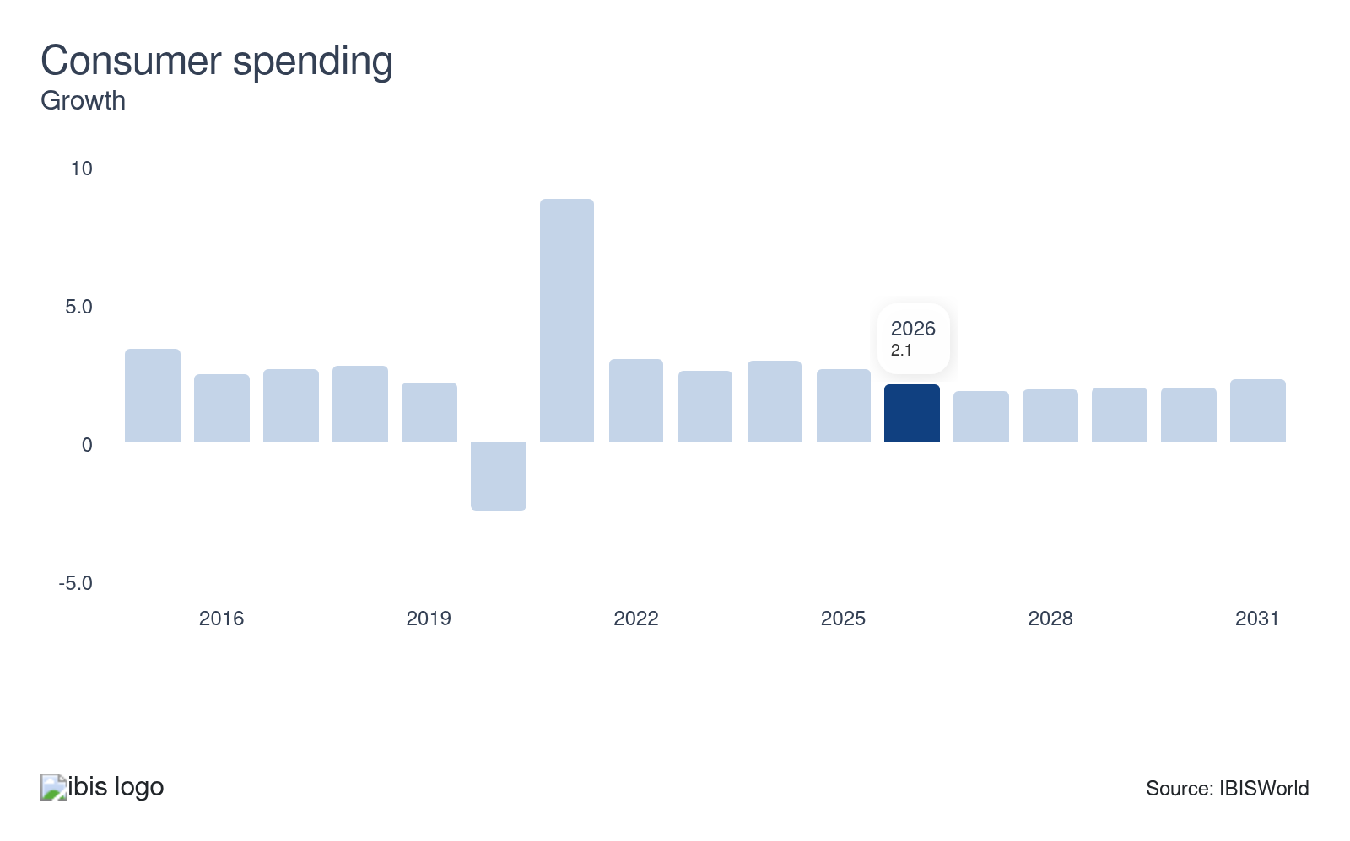
An increase in consumer spending indicates that US consumers are purchasing goods that must be shipped from foreign markets or other regions within the United States. Since many manufacturers rely on waterborne freight transportation to ship goods to consumers, rising consumer spending typically increases demand for water transportation and its support services.
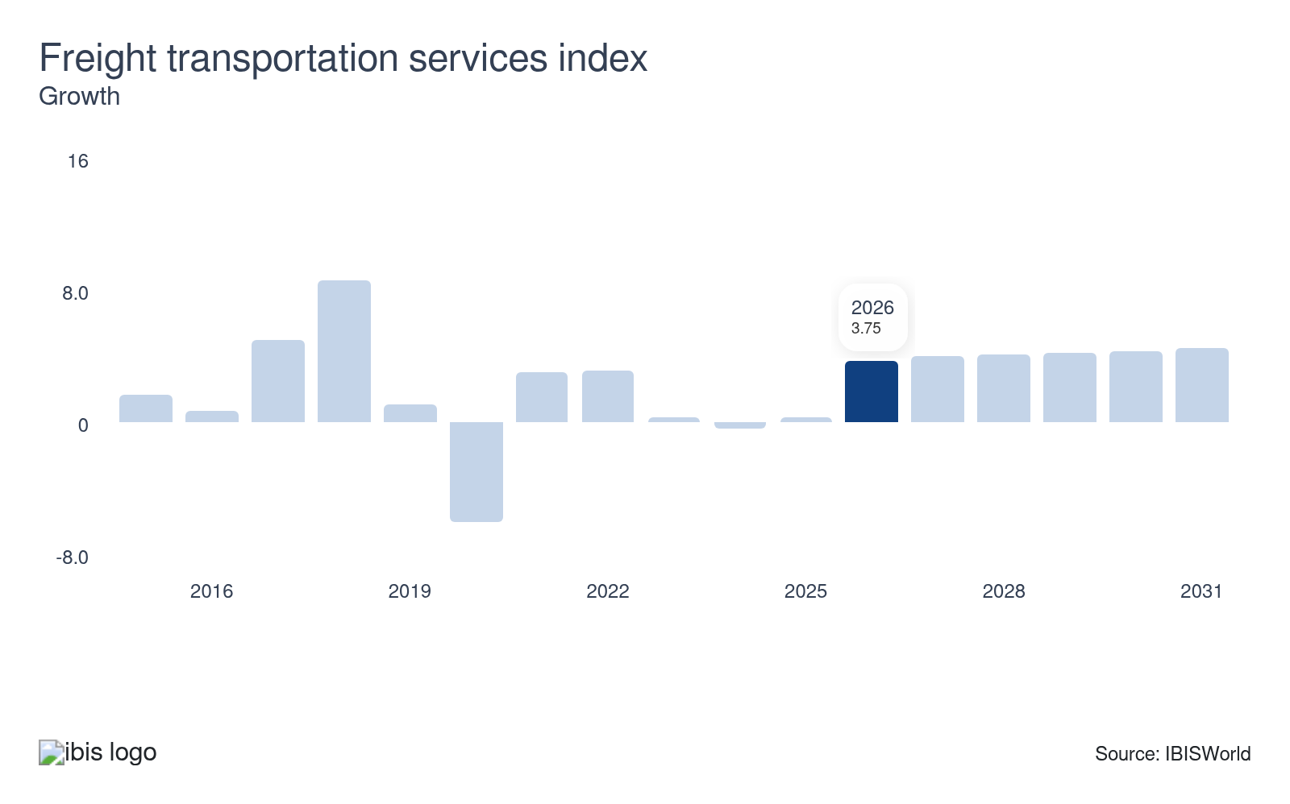
The freight transportation services index measures the annual output of the US transportation sector. An increase in freight shipping demand tends to coincide with a rise in demand for transportation support services. The freight recession reduced the growth of freight transportation services. This reduced the revenue from ports and harbors. A drop in the freight transportation services index could pose a threat to port and harbor operations.
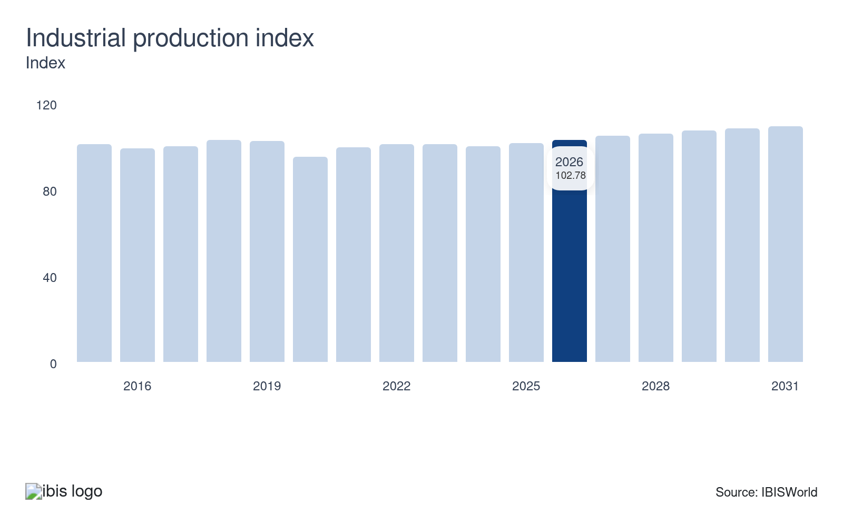
The industrial production index measures the output from the US mining, manufacturing, electric and gas industries. The manufacturing sector relies heavily on waterborne transportation for importing and exporting goods. If manufacturing output increases, the demand for water transportation and its support services also climbs.
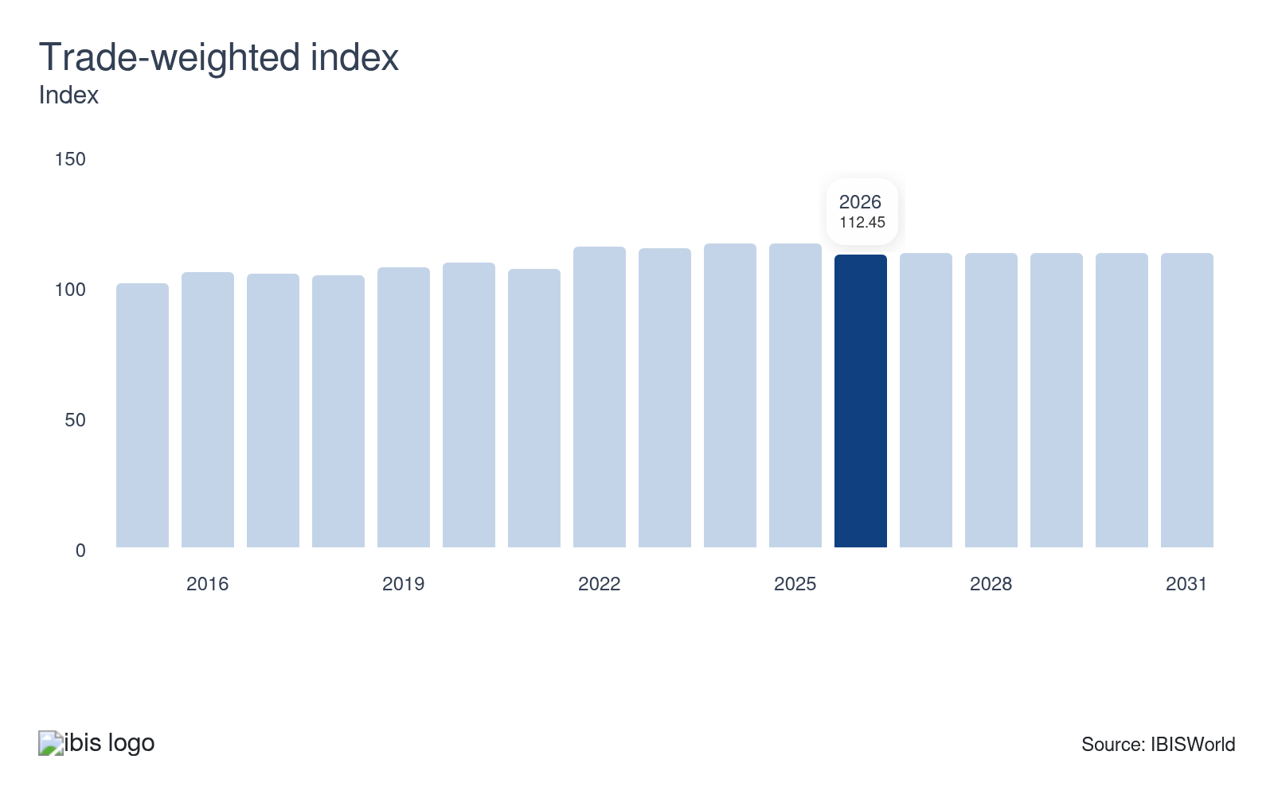
The trade-weighted index measures the strength of the US dollar relative to the currencies of the nation’s trading partners. When the index is high, the US dollar is considered relatively strong compared to other currencies. This incentivizes imports because they become less expensive. Conversely, when the index drops, exports benefit from more competitive pricing on the world stage. Tariffs have contributed to growth in the trade-weighted index over the five years through 2025.

Regulation & Policy
Moderate | Steady

What regulations impact the industry?

The Maritime Administration
Working directly under the Department of Transportation (DOT), the Maritime Administration publishes security reports for the maritime industry to ensure the best security practices are implemented. These practices are highlighted in the Maritime Transportation Security Act of 2002, enacted in the wake of 9/11. Under the current administration, MARAD's role has expanded well beyond security oversight into active industrial policy. The FY2027 White House budget proposes $1.5 billion for its Maritime Action Plan. This includes $500.0 million specifically for port infrastructure improvements and $355.0 million for a new Commercial Shipbuilding Infrastructure Development Program.

The South Coast Air Quality Management District (AQMD)
The Air Quality Management District (AQMD) calls for zero-emission truck fleets at regional ports, and the Clean Air Action Plan has recently been adopted. Most notably, the Port of Los Angeles and the Port of Long Beach, two of the industry's largest operators, have adopted the plans, which target a zero-emission truck fleet by 2036 and an overall 80.0% reduction in emissions by 2050. However, the Trump administration revoked California's authority to mandate EVs and its federal regulatory power over greenhouse gas emissions. This strips the federal enforcement backstop that previously supported these targets.

The US Customs and Boarder Protection
US Customs and Border Protection plays a vital role at ports by inspecting cargo. Ports and harbors facilitate global and domestic trade, so the customs services work to prevent potentially hazardous or illegal substances from entering the US. The most significant CBP regulatory shift in decades occurred in February 2025, when President Trump's executive order eliminated the de minimis exemption for all Chinese-origin imports. The exemption was subsequently modified as part of the May 2025 US-China tariff negotiations. Previously exempt goods are subject to a 30.0% tariff as of April 2026 rather than the original 145.0% rate.

Occupational Safety and Health Administration (OSHA)
Ports and Harbors operate potentially hazardous machinery. OSHA is responsible for licensing, training and setting a code of conduct for on-site operations. This limits health hazards while promoting a safe working environment for personnel. Additionally, OSHA outlines guidelines for proper cargo handling on ships to help limit the risk of accidents and injuries.

Tariffs
US ports face an ever-changing landscape of trade and customs rules. The elimination of the de minimis exemption for small-value Chinese imports. These changes require ports to manage increased customs documentation and inspections, adapt to shifting cargo origins and handle higher compliance costs. The Harbor Maintenance Tax and recent federal laws ensure steady funding for dredging and maintenance, but also require careful fee administration and reporting. Because ports and harbors rely on trade to generate revenue, tariffs pose a threat by reducing demand for port services.

Environmental Protection Agency (EPA)
Environmental protection rules, such as the Clean Air Act, the Clean Water Act and newer EPA programs, have historically required ports to phase in zero-emission equipment and comply with federal and state standards. The Trump administration announced a large deregulatory action in February 2026. It rolled back broad Clean Air Act and Clean Water Act enforcement mechanisms and revoked California's authority to mandate electric vehicles and regulate greenhouse gas emissions from port equipment. State-level programs are the primary regulatory driver for port emissions compliance as of April 2026. Safety in port operations is closely regulated by OSHA, which sets standards for hazardous jobs such as crane operations and cargo handling. Labor regulations, including multi-year union contracts and the Jones Act's requirements for US-built and operated vessels, add to the complex compliance environment. This keeps wages high and practices stable.

Assistance
Moderate | Steady

What assistance is available to this industry?

Port Security Grant Program (PSGP) and Harbor Maintenance Trust Fund (HMTF)
The Port Security Grant Program offers assistance for port and harbor operators. More than $1.0 billion has been spent on this program since September 11, 2001. Funds have been allocated for lighting, fencing, security cameras, guard gates, access-control systems and interoperable communications. Through enhanced port security, operators promote a safe environment for workers. Security and resilience efforts are also supported with the Harbor Maintenance Trust Fund (HMTF), which reliably covers dredging and navigational needs to clear channels. The Water Resources Development Act (WRDA) of 2020 authorized full utilization of the HMTF’s $10.0 billion balance, with $500.0 million appropriated in fiscal year 2021 and increasing by $100.0 million annually until 2030.

Infrastructure Investment and Jobs Act (IIJA)
The $1.2 trillion Infrastructure Investment and Jobs Act provides funding for port infrastructure. Within the IIJA, the Maritime Administration’s Port Infrastructure Development Program (PIDP) distributes $450.0 to $500.0 million per year for dock expansion, rail links, cargo handling equipment and safety upgrades. The IIJA supplies an additional $5 billion for port resilience, electrification and intermodal links. Ports benefit from stacked funding streams, allowing them to pursue large-scale capital projects, expand terminal capacity and implement advanced technology. The US Marine Highway Program Grants also contribute to upgrading port facilities and modernizing operations. These investments in infrastructure improvements support the industry by enhancing operational efficiency and capacity. Due to a recent executive order under the Trump administration, funding for this bill is expected to pause in 2026.

Environmental Protection Agency (EPA), Diesel Emissions Reduction Act (DERA) grants and federal funds
The EPA’s Clean Ports Program and DERA grants provide more than $3.0 billion for zero-emission equipment, shore power and air quality planning, making environmental compliance more affordable. The Port of Los Angeles and the Port of Virginia are the most sustainable ports in the US. Simultaneously, federal workforce grants back union apprenticeships, technology training, and maritime career pathways, ensuring the sector’s competitiveness as automation and clean energy drive operational change.

American Association of Port Authorities (AAPA)
The AAPA supports its members through representation and advocacy, professional development and education, relationship-building and public awareness. The association represents over 130 port authorities in the US, the Caribbean, Canada and Latin America. The AAPA is also responsible for sustainability, advocating for protecting the environment and supporting ports transitioning to a net-zero future.

Federal Assistance
Ports and harbors are supported through various infrastructure-related programs, including the Better Utilizing Investments to Leverage Development (BUILD) Grants. This program supports one of the most vital infrastructures in the US and keeps the ports in top condition.

9. Financial Benchmarks
https://my.ibisworld.com/us/en/industry/48831/financial-benchmarks
Profit Margin  12.7 %  ↑ Higher than sector | Average Wage  $81,158  ↑ Higher than sector | Largest Cost  Purchases  41.5% of Revenue

Key Takeaways
- Profit is supported by value-added services, cloud efficiency gains and high leverage on incremental revenue. Profit is at risk if tariff-driven volume softness persists into 2026 without a corresponding reduction in fixed costs.
- Purchases remain the largest cost category, driven by contracted dredging, fuel, maintenance and environmental compliance spending that inflation has pushed higher. The proposed vessel fees could increase purchase costs.
- The International Longshoremen's Association contract structurally raised wages. At the same time, tight unemployment in the transportation sector gives labor sustained bargaining power. Depreciation continues to drop because revenue share and grant funding reduce the net depreciable base.

Cost Structure

Chart displays current year only in the PDF version of this report. You can view and download chart for all other years associated with this industry on my.ibisworld.com.

What trends impact industry costs?

Infrastructure scale and value-added services increase profit
- Deeper channels, larger cranes and automated loading systems allow ports to handle larger vessels and higher cargo volumes without proportional increases in costs. Value-added services such as warehousing, logistics hubs and premium cargo handling also generate higher profit. Ports' limited competition in most regional markets sustains pricing power.
- Once operating costs are covered, a significant share of each incremental dollar of revenue flows directly to profit. The International Longshoremen's Association (ILA) six-year contract provides labor cost predictability and cloud-based operations platforms at ports like Los Angeles and Long Beach. This reduces scheduling inefficiencies. If automation investments mature and debt on prior capital projects amortizes, profit could expand alongside recovering cargo volumes through 2027.

Dredging contracts and fuel costs keep purchases elevated
- Purchases have grown as the largest cost category because higher cargo volumes demand more fuel for tugboats and cranes, maintenance materials, spare parts and outsourced logistics contracts. These were all inflated by persistent input cost pressures. Ports' growing reliance on third-party contractors for specialized tasks like dredging, technical upgrades and environmental services also increased purchases.
- Regulatory compliance requirements for clean fuels, shore power and safety equipment add further spending pressure. Ports have limited ability to offset it through fee increases constrained by public tariff-setting processes. Proposed fees on Chinese-built vessel calls, if enacted, could raise purchases through 2026.

Steady labor needs and union contracts keep wages high
- Wages remain one of the most prominent expenses for ports because round-the-clock operations require skilled longshoremen, crane operators, maintenance crews and security personnel whose roles cannot be fully automated. Multi-year union agreements set predictable wage growth and minimum staffing levels. This keeps labor costs closely tied to cargo volume rather than offering the flexibility of variable cost structures.
- The International Longshoremen's Association ratified a six-year contract that raises base hourly rates by 62.0%. This is likely to keep wages elevated for East and Gulf Coast ports through September 2030. Over time, hazard premiums and pension obligations also contribute to high wages. The transportation sector's tight 3.4% unemployment rate as of March 2026, according to the BLS, gives unions sustained leverage heading into the next contract cycle.

Revenue growth, asset longevity and targeted upgrades pushes depreciation lower
- Port revenue has consistently grown faster than new capital spending on major infrastructure. Ports have focused investments on targeted automation upgrades, sustainable retrofits and maintenance. This suggests annual depreciation is spread across assets with long useful lives.
- Public grant programs frequently offset depreciable asset bases. Leasing arrangements for specialized equipment further reduce what ports carry on their books. If revenue growth continues to outpace new capital additions, depreciation's share of total costs will likely continue to drop through 2026.

Scale and automation reduce other costs
- Other costs, including insurance, administration and compliance, have fallen because strong throughput growth has expanded revenue faster than these expenses have grown. Automation platforms that manage elevated traffic without proportional increases in support staff have further reduced overhead. This allowed ports to operate more complex logistics networks without equivalent administrative cost growth.
- Persistent spending on environmental compliance, cybersecurity, community programs and external consulting ensures these costs remain a structurally significant line item regardless of efficiency gains. The US Coast Guard's mandatory cybersecurity rule, effective July 2025, added new compliance obligations and state-level environmental programs. These have generated their own administrative and reporting costs that are unlikely to drop if states increase oversight.
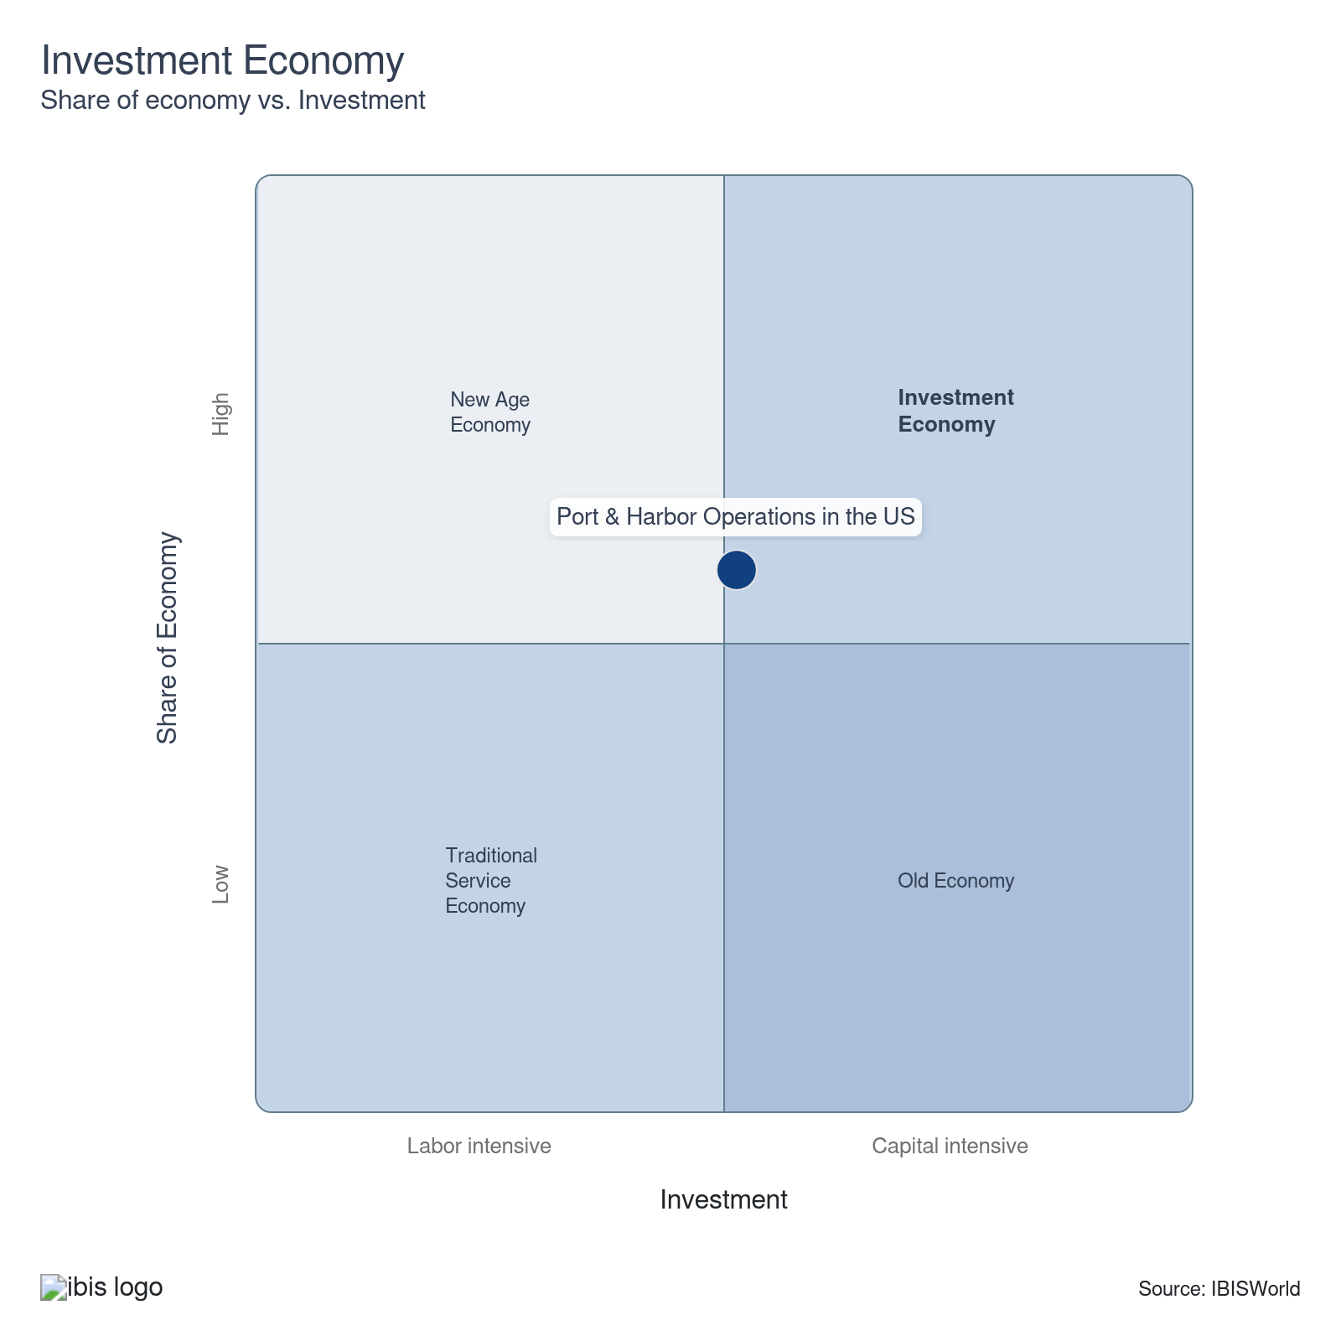

Financial Ratios

Earnings Ratios
Ratio | 2020 | 2021 | 2022 | 2023 | 2024 | 3-Year | 5-Year | 10-Year
EBIT/Revenue | 13.5 | 25.7 | 4.9 | 6.2 | 13.0 | 9.6 | 12.5 | 10.7
EBITDA/Revenue | 20.0 | 30.5 | 10.2 | 9.4 | 21.4 | 15.4 | 17.9 | 16.1
Leverage Ratio | 5.0 | 3.3 | 9.8 | 10.7 | 4.7 | 7.7 | 7.1 | 7.2

Industry Tax Structure
Ratio | 2020 | 2021 | 2022 | 2023 | 2024 | 3-Year | 5-Year | 10-Year
Taxes Paid/Revenue | 1.3 | 0.5 | 0.7 | 1.4 | 1.1 | 1.3 | 1.0 | 0.9

Income Statement
Ratio | 2020 | 2021 | 2022 | 2023 | 2024 | 3-Year | 5-Year | 10-Year
Total Revenue | 100.0 | 100.0 | 100.0 | 100.0 | 100.0 | 100.0 | 100.0 | 100.0
Business receipts | 90.7 | 91.7 | 93.9 | 93.6 | 97.5 | 95.5 | 94.2 | 93.3
Cost of goods | 43.0 | 40.0 | 52.8 | 45.5 | 33.6 | 39.6 | 43.0 | 47.2
Gross Profit | 57.0 | 60.0 | 47.2 | 54.5 | 66.4 | 60.4 | 57.0 | 52.8
Expenses
Salaries and wages | 4.9 | 2.5 | 3.4 | 5.7 | 3.9 | 4.8 | 3.9 | 4.3
Advertising | 0.5 | 1.7 | 0.2 | 1.1 | 0.8 | 0.9 | 0.9 | 0.6
Depreciation | 4.4 | 2.4 | 2.9 | 2.2 | 1.8 | 2.0 | 2.3 | 3.1
Depletion | 1.8 | 1.1 | 1.1 | 0.5 | 0.9 | 0.7 | 0.9 | 1.2
Amortization | 0.3 | 1.2 | 1.3 | 0.5 | 5.7 | 3.1 | 2.2 | 1.1
Rent paid | 1.2 | 0.5 | 0.8 | 1.7 | 1.6 | 1.7 | 1.2 | 1.1
Repairs | 0.7 | 0.5 | 0.6 | 0.9 | 0.4 | 0.7 | 0.6 | 0.6
Bad debts | 0.1 | 0.2 | 0.0 | 1.1 | 0.4 | 0.8 | 0.4 | 0.3
Employee benefit programs | 2.2 | 1.1 | 1.3 | 2.3 | 2.0 | 2.1 | 1.7 | 1.8
Compensation of officers | 1.2 | 1.0 | 1.1 | 3.6 | 10.2 | 6.9 | 4.0 | 2.4
Taxes paid | 1.3 | 0.5 | 0.7 | 1.4 | 1.1 | 1.3 | 1.0 | 0.9
Interest Income | 1.0 | 0.6 | 0.6 | 0.4 | 1.0 | 0.7 | 0.6 | 0.8
Other Income
Royalties | 0.7 | 1.1 | 0.5 | 0.3 | 0.8 | 0.5 | 0.7 | 0.6
Rent Income | 4.1 | 2.7 | 2.1 | 0.7 | 0.0 | 0.4 | 1.4 | 2.2
Net Income | 8.8 | 23.7 | 2.3 | 2.3 | 3.9 | 3.1 | 8.0 | 6.6
Charitable contributions | 0.1 | 0.2 | 0.1 | 0.2 | 0.1 | 0.1 | 0.1 | 0.1
Dividends | 0.1 | 1.0 | 0.0 | 1.8 | 0.1 | 1.0 | 0.7 | 0.4
Interest paid | 3.4 | 1.5 | 1.9 | 2.5 | 8.0 | 5.3 | 3.5 | 3.1
Net gain, noncapital assets | 1.3 | 0.9 | 0.7 | 0.4 | 0.0 | 0.2 | 0.5 | 0.8
Net long-term capital gain less net short-term loss | 0.3 | 0.4 | 0.3 | 0.2 | 0.3 | 0.2 | 0.3 | 0.3
Net loss, noncapital assets | 2.0 | 1.2 | 1.3 | 0.5 | 0.1 | 0.3 | 0.8 | 1.2
Net short-term capital gain less net long-term loss | 0.1 | 0.0 | 0.2 | 1.1 | 0.1 | 0.6 | 0.3 | 0.2
Other deductions | 23.1 | 19.9 | 27.5 | 26.7 | 23.3 | 25.0 | 24.4 | 23.3
Other receipts | 1.6 | 1.6 | 1.6 | 1.6 | 0.2 | 0.9 | 1.3 | 1.4
Pension, profit-sharing, etc., plans | 1.0 | 0.6 | 0.7 | 1.3 | 2.3 | 1.8 | 1.2 | 1.0

Balance Sheet
Ratio | 2020 | 2021 | 2022 | 2023 | 2024 | 3-Year | 5-Year | 10-Year
Assets
Cash and Equivalents | 6.1 | 5.6 | 6.9 | 6.6 | 5.8 | 6.2 | 6.2 | 6.0
Notes and accounts receivable | 10.4 | 13.2 | 16.4 | 14.8 | 14.9 | 14.9 | 14.8 | 12.8
Allowance for bad debts | 0.2 | 0.3 | 0.5 | 0.7 | 0.7 | 0.7 | 0.6 | 0.5
Inventories | 2.5 | 2.8 | 1.9 | 7.6 | 11.2 | 9.4 | 5.9 | 4.1
Other current assets | 7.4 | 4.7 | 9.3 | 6.3 | 5.8 | 6.1 | 6.5 | 5.8
Other investments | 8.7 | 11.8 | 7.3 | 19.1 | 17.7 | 18.4 | 14.0 | 9.4
Property, Plant and Equipment | 52.5 | 54.5 | 45.1 | 29.3 | 33.0 | 31.2 | 40.5 | 49.3
Accumulated depreciation | 18.1 | 24.8 | 22.8 | 17.3 | 19.8 | 18.6 | 21.2 | 23.9
Intangible assets (Amortizable) | 10.7 | 10.2 | 12.0 | 14.5 | 12.9 | 13.7 | 12.4 | 15.4
Accumulated amortization | 1.8 | 1.5 | 0.3 | 2.4 | 1.9 | 2.2 | 1.5 | 2.5
Other assets | 7.2 | 8.6 | 9.9 | 7.4 | 7.2 | 7.3 | 8.3 | 8.0
Total assets | 100.0 | 100.0 | 100.0 | 100.0 | 100.0 | 100.0 | 100.0 | 100.0
Accounts payable | 12.9 | 7.8 | 10.4 | 8.8 | 9.6 | 9.2 | 9.2 | 8.9
Liabilities and Net Worth
Mort, notes, and bonds under 1 yr | 5.4 | 7.2 | 6.9 | 8.6 | 9.8 | 9.2 | 8.1 | 7.9
Other current liabilities | 8.8 | 7.6 | 9.1 | 10.6 | 8.8 | 9.7 | 9.0 | 8.6
Loans from shareholders | 1.8 | 1.2 | 2.3 | 2.2 | 2.9 | 2.5 | 2.1 | 3.0
Mort, notes, bonds, 1 yr or more | 25.4 | 35.5 | 30.6 | 34.0 | 35.2 | 34.6 | 33.8 | 32.6
Other liabilities | 25.1 | 19.5 | 17.9 | 11.6 | 11.4 | 11.5 | 15.1 | 17.2
Total liabilities | 100.0 | 100.0 | 100.0 | 100.0 | 100.0 | 100.0 | 100.0 | 100.0
Capital stock | -1.4 | 3.4 | 2.5 | 2.2 | 0.0 | 1.1 | 2.0 | 1.3
Additional paid-in capital | 18.7 | 24.0 | 22.6 | 16.3 | 13.3 | 14.8 | 19.1 | 19.1
Retained earnings, appropriated | -3.1 | 0.3 | 0.4 | -2.0 | -1.2 | -1.6 | -0.6 | -1.1
Retained earnings-unappropriated | 17.0 | 15.0 | 12.0 | 23.2 | 24.1 | 23.7 | 18.6 | 14.7
Cost of treasury stock | 10.7 | 21.6 | 14.6 | 15.5 | 13.8 | 14.6 | 16.4 | 12.2
Net worth | 20.7 | 21.1 | 22.9 | 24.2 | 22.5 | 23.3 | 22.7 | 21.9
Accumulated depletion | 4.8 | 2.5 | 2.3 | 0.6 | 0.4 | 0.5 | 1.4 | 2.5
Depletable assets | 11.7 | 10.1 | 11.1 | 2.3 | 1.6 | 1.9 | 6.3 | 9.0
Government Obligations | 0.2 | 0.2 | 0.2 | 0.7 | 0.5 | 0.6 | 0.4 | 0.3
Land | 3.0 | 2.8 | 4.2 | 3.3 | 3.3 | 3.3 | 3.4 | 3.3
Loans to shareholders | 0.6 | 0.6 | 0.1 | 1.1 | 1.3 | 1.2 | 0.8 | 1.1
Mortgage and real estate loans | 4.1 | 4.0 | 1.4 | 7.6 | 7.3 | 7.5 | 5.1 | 4.7
Tax Exempt Securities | 0.0 | 0.0 | 0.0 | 0.5 | 0.4 | 0.5 | 0.2 | 0.1

Liquidity Ratios
Ratio | 2020 | 2021 | 2022 | 2023 | 2024 | 3-Year | 5-Year | 10-Year
Current Ratio | 1.0 | 1.2 | 1.3 | 1.3 | 1.4 | 1.4 | 1.3 | 1.2
Quick Ratio | 0.9 | 1.1 | 1.3 | 1.1 | 1.0 | 1.0 | 1.1 | 1.0
Sales/Receivables | 9.6 | 7.6 | 6.1 | 6.8 | 6.7 | 6.7 | 6.8 | 8.1
Days' Receivables | 38.1 | 48.2 | 59.8 | 54.0 | 54.4 | 54.2 | 54.1 | 46.9
Days' Inventory | 21.6 | 25.2 | 13.2 | 60.7 | 121.7 | 91.2 | 55.2 | 34.9
Inventory Turnover | 16.9 | 14.5 | 27.6 | 6.0 | 3.0 | 4.5 | 12.8 | 16.7
Payables Turnover | 3.3 | 5.1 | 5.1 | 5.2 | 3.5 | 4.3 | 4.7 | 5.8
Days' Payables | 109.1 | 71.0 | 72.1 | 70.6 | 104.1 | 87.4 | 79.5 | 70.6
Sales/Working Capital | -499.8 | 21.5 | 10.6 | 10.3 | 8.7 | 9.5 | 12.8 | -53.8

Coverage Ratios
Ratio | 2020 | 2021 | 2022 | 2023 | 2024 | 3-Year | 5-Year | 10-Year
Interest Coverage | 4.0 | 17.4 | 2.6 | 2.5 | 1.6 | 2.1 | 6.0 | 4.5
Debt Service Coverage Ratio | 5.6 | 14.6 | 4.1 | 4.9 | 11.1 | 8.0 | 8.7 | 12.4

Leverage Ratios
Ratio | 2020 | 2021 | 2022 | 2023 | 2024 | 3-Year | 5-Year | 10-Year
Fixed Assets/Net Worth | 5.0 | 5.0 | 4.3 | 2.9 | 3.2 | 3.1 | 3.9 | 4.9
Debt/Net Worth | 4.8 | 4.7 | 4.4 | 4.1 | 4.4 | 4.3 | 4.4 | 4.6
Tangible Net Worth | 20.7 | 21.1 | 22.9 | 24.2 | 22.5 | 23.3 | 22.7 | 21.9

Operating Ratios
Ratio | 2020 | 2021 | 2022 | 2023 | 2024 | 3-Year | 5-Year | 10-Year
Return on Net Worth, % | 65.2 | 121.8 | 21.6 | 25.7 | 57.9 | 41.8 | 56.7 | 50.5
Return on Assets, % | 13.5 | 25.7 | 4.9 | 6.2 | 13.0 | 9.6 | 12.5 | 10.7
Sales/Total Assets | 1.0 | 1.0 | 1.0 | 1.0 | 1.0 | 1.0 | 1.0 | 1.0
EBITDA/Revenue | 20.0 | 30.5 | 10.2 | 9.4 | 21.4 | 15.4 | 17.9 | 16.1
EBIT/Revenue | 13.5 | 25.7 | 4.9 | 6.2 | 13.0 | 9.6 | 12.5 | 10.7

Cash Flow & Debt Service Ratios (% of sales)
Ratio | 2020 | 2021 | 2022 | 2023 | 2024 | 3-Year | 5-Year | 10-Year
Cash from Trading | 47.8 | 67.6 | 48.6 | 48.9 | 62.1 | 55.5 | 56.8 | 52.3
Cash after Operations | 38.5 | 62.7 | 39.4 | 40.4 | 43.9 | 42.2 | 46.6 | 43.3
Net Cash after Operations | 37.5 | 64.3 | 38.4 | 39.6 | 51.6 | 45.6 | 48.5 | 44.8
Debt Service P&I Coverage | 3.8 | 7.0 | 4.0 | 3.1 | 2.7 | 2.9 | 4.2 | 3.9
Interest Coverage (Operating Cash) | 11.0 | 43.5 | 20.0 | 15.8 | 6.4 | 11.1 | 21.5 | 18.1

Valuation Multiples

Valuation Multiples
Ratio | 2020 | 2021 | 2022 | 2023 | 2024 | 3-Year | 5-Year | 10-Year
EV/Revenue | 0.5 | 0.6 | 0.6 | 0.6 | 0.6 | 0.6 | 0.6 | 0.6
EV/EBITDA | 2.0 | 2.0 | 2.7 | 3.3 | 1.9 | 2.7 | 2.4 | 2.2
EV/EBIT | 3.7 | 3.1 | 5.6 | 5.0 | 3.2 | 4.6 | 4.1 | 3.6

Key Ratios
Year | Revenue per Employee  ($) | Revenue per Enterprise  ($ Million) | Employees per Estab.  (Units) | Employees per Enterprise  (Units) | Average Wage  ($) | Wages/ Revenue  (%) | Estab. per Enterprise  (Units) | IVA/ Revenue  (%)
2003 | 303,343 | 11.6 | 28.8 | 38.4 | 73,890 | 24.4 | 1.3 | 1.3
2004 | 279,329 | 11.2 | 29.4 | 40.0 | 71,956 | 25.8 | 1.4 | 41.8
2005 | 254,176 | 10.5 | 30.5 | 41.2 | 68,459 | 26.9 | 1.3 | 39.8
2006 | 266,527 | 10.7 | 30.6 | 40.0 | 71,641 | 26.9 | 1.3 | 40.2
2007 | 280,717 | 10.5 | 29.5 | 37.6 | 73,153 | 26.1 | 1.3 | 37.9
2008 | 368,118 | 9.2 | 20.9 | 24.9 | 74,637 | 20.3 | 1.2 | 31.9
2009 | 518,836 | 12.4 | 19.8 | 23.8 | 72,256 | 13.9 | 1.2 | 26.2
2010 | 557,072 | 11.6 | 16.9 | 20.9 | 87,193 | 15.7 | 1.2 | 28.6
2011 | 580,427 | 13.9 | 19.3 | 23.9 | 88,623 | 15.3 | 1.2 | 27.9
2012 | 129,914 | 8.7 | 48.4 | 67.0 | 74,121 | 57.1 | 1.4 | 69.8
2013 | 514,694 | 11.4 | 18.3 | 22.2 | 82,646 | 16.1 | 1.2 | 29.2
2014 | 548,281 | 12.8 | 19.3 | 23.3 | 79,766 | 14.5 | 1.2 | 28.4
2015 | 511,992 | 14.4 | 23.3 | 28.1 | 74,028 | 14.5 | 1.2 | 30.2
2016 | 502,100 | 14.6 | 24.1 | 29.1 | 70,350 | 14.0 | 1.2 | 25.3
2017 | 465,009 | 16.0 | 26.9 | 34.5 | 72,827 | 15.7 | 1.3 | 26.5
2018 | 391,759 | 15.6 | 31.4 | 39.7 | 84,047 | 21.5 | 1.3 | 36.3
2019 | 364,626 | 16.5 | 35.8 | 45.2 | 81,076 | 22.2 | 1.3 | 37.0
2020 | 382,507 | 17.3 | 35.2 | 45.2 | 81,143 | 21.2 | 1.3 | 34.3
2021 | 398,108 | 18.7 | 36.3 | 47.0 | 85,250 | 21.4 | 1.3 | 36.6
2022 | 421,910 | 21.1 | 38.5 | 50.1 | 82,377 | 19.5 | 1.3 | 33.9
2023 | 407,850 | 22.5 | 42.7 | 55.3 | 81,463 | 20.0 | 1.3 | 39.7
2024 | 404,204 | 22.9 | 43.7 | 56.6 | 81,319 | 20.1 | 1.3 | 40.7
2025 | 400,605 | 23.2 | 44.7 | 57.8 | 81,180 | 20.3 | 1.3 | 41.0
2026 | 400,199 | 23.6 | 45.5 | 59.0 | 81,158 | 20.3 | 1.3 | 38.7
2027 | 402,013 | 24.2 | 46.2 | 60.2 | 81,234 | 20.2 | 1.3 | 39.4
2028 | 403,323 | 24.7 | 47.1 | 61.4 | 81,281 | 20.2 | 1.3 | 39.3
2029 | 404,476 | 25.2 | 47.8 | 62.4 | 81,327 | 20.1 | 1.3 | 39.4
2030 | 405,844 | 25.7 | 48.5 | 63.3 | 81,386 | 20.1 | 1.3 | 40.0
2031 | 407,051 | 26.1 | 48.9 | 64.1 | 81,433 | 20.0 | 1.3 | 40.3
2032 | 408,292 | 26.4 | 49.4 | 64.7 | 81,484 | 20.0 | 1.3 | 40.3
*Figures are inflation adjusted to 2025
*Figures are inflation adjusted to 2025

10. Key Statistics
https://my.ibisworld.com/us/en/industry/48831/key-statistics

Industry Data

Values
Year | Revenue  ($ Million) | IVA  ($ Million) | Estab.  (Units) | Enterprises  (Units) | Employment  (Units) | Wages  ($ Million)
2003 | 1,945.3 | N/A | 223 | 167 | 6,413 | 473.9
2004 | 1,924.0 | 804.5 | 234 | 172 | 6,888 | 495.6
2005 | 1,894.4 | 753.8 | 244 | 181 | 7,453 | 510.2
2006 | 1,866.2 | 749.5 | 229 | 175 | 7,002 | 501.6
2007 | 1,845.2 | 698.9 | 223 | 175 | 6,573 | 480.8
2008 | 2,064.4 | 658.7 | 268 | 225 | 5,608 | 418.6
2009 | 2,646.1 | 694.0 | 258 | 214 | 5,100 | 368.5
2010 | 2,698.5 | 770.7 | 287 | 232 | 4,844 | 422.4
2011 | 2,863.2 | 798.7 | 255 | 206 | 4,933 | 437.2
2012 | 3,299.3 | 2,302.1 | 525 | 379 | 25,396 | 1,882.4
2013 | 3,602.9 | 1,050.9 | 383 | 315 | 7,000 | 578.5
2014 | 3,711.3 | 1,053.4 | 351 | 290 | 6,769 | 539.9
2015 | 4,021.7 | 1,214.7 | 337 | 280 | 7,855 | 581.5
2016 | 4,018.3 | 1,016.1 | 332 | 275 | 8,003 | 563.0
2017 | 4,187.4 | 1,108.6 | 335 | 261 | 9,005 | 655.8
2018 | 4,356.0 | 1,579.7 | 354 | 280 | 11,119 | 934.5
2019 | 4,569.5 | 1,692.8 | 350 | 277 | 12,532 | 1,016.0
2020 | 4,739.6 | 1,627.3 | 352 | 274 | 12,391 | 1,005.4
2021 | 5,037.3 | 1,844.4 | 349 | 269 | 12,653 | 1,078.7
2022 | 5,622.8 | 1,906.1 | 346 | 266 | 13,327 | 1,097.8
2023 | 5,682.6 | 2,256.0 | 326 | 252 | 13,933 | 1,135.0
2024 | 5,816.1 | 2,364.9 | 329 | 254 | 14,389 | 1,170.1
2025 | 5,906.1 | 2,421.9 | 330 | 255 | 14,743 | 1,196.8
2026 | 6,021.4 | 2,329.4 | 331 | 255 | 15,046 | 1,221.1
2027 | 6,191.0 | 2,439.4 | 333 | 256 | 15,400 | 1,251.0
2028 | 6,360.4 | 2,499.2 | 335 | 257 | 15,770 | 1,281.8
2029 | 6,533.1 | 2,571.9 | 338 | 259 | 16,152 | 1,313.6
2030 | 6,709.0 | 2,680.5 | 341 | 261 | 16,531 | 1,345.4
2031 | 6,892.6 | 2,774.5 | 346 | 264 | 16,933 | 1,378.9
2032 | 7,080.6 | 2,856.2 | 351 | 268 | 17,342 | 1,413.1

*Figures are inflation adjusted to 2025

Annual Change
Year | Revenue  % | IVA  % | Estab.  % | Enterprises  % | Employment  % | Wages  %
2003 | N/A | N/A | N/A | N/A | N/A | N/A
2004 | -1.1 | N/A | 4.9 | 3.0 | 7.4 | 4.6
2005 | -1.5 | -6.3 | 4.3 | 5.2 | 8.2 | 2.9
2006 | -1.5 | -0.6 | -6.1 | -3.3 | -6.1 | -1.7
2007 | -1.1 | -6.7 | -2.6 | 0.0 | -6.1 | -4.1
2008 | 11.9 | -5.8 | 20.2 | 28.6 | -14.7 | -12.9
2009 | 28.2 | 5.4 | -3.7 | -4.9 | -9.1 | -12.0
2010 | 2.0 | 11.0 | 11.2 | 8.4 | -5.0 | 14.6
2011 | 6.1 | 3.6 | -11.1 | -11.2 | 1.8 | 3.5
2012 | 15.2 | 188.2 | 105.9 | 84.0 | 414.8 | 330.6
2013 | 9.2 | -54.4 | -27.0 | -16.9 | -72.4 | -69.3
2014 | 3.0 | 0.2 | -8.4 | -7.9 | -3.3 | -6.7
2015 | 8.4 | 15.3 | -4.0 | -3.4 | 16.0 | 7.7
2016 | -0.1 | -16.4 | -1.5 | -1.8 | 1.9 | -3.2
2017 | 4.2 | 9.1 | 0.9 | -5.1 | 12.5 | 16.5
2018 | 4.0 | 42.5 | 5.7 | 7.3 | 23.5 | 42.5
2019 | 4.9 | 7.2 | -1.1 | -1.1 | 12.7 | 8.7
2020 | 3.7 | -3.9 | 0.6 | -1.1 | -1.1 | -1.0
2021 | 6.3 | 13.3 | -0.9 | -1.8 | 2.1 | 7.3
2022 | 11.6 | 3.3 | -0.9 | -1.1 | 5.3 | 1.8
2023 | 1.1 | 18.4 | -5.8 | -5.3 | 4.5 | 3.4
2024 | 2.3 | 4.8 | 0.9 | 0.8 | 3.3 | 3.1
2025 | 1.5 | 2.4 | 0.3 | 0.4 | 2.5 | 2.3
2026 | 2.0 | -3.8 | 0.3 | 0.0 | 2.1 | 2.0
2027 | 2.8 | 4.7 | 0.6 | 0.4 | 2.4 | 2.4
2028 | 2.7 | 2.5 | 0.6 | 0.4 | 2.4 | 2.5
2029 | 2.7 | 2.9 | 0.9 | 0.8 | 2.4 | 2.5
2030 | 2.7 | 4.2 | 0.9 | 0.8 | 2.3 | 2.4
2031 | 2.7 | 3.5 | 1.5 | 1.1 | 2.4 | 2.5
2032 | 2.7 | 2.9 | 1.4 | 1.5 | 2.4 | 2.5

*Figures are inflation adjusted to 2025

DISCLAIMER
This product has been supplied by IBISWorld Inc. (‘IBISWorld’) solely for use by its authorized licenses strictly in accordance with their license agreements with IBISWorld. IBISWorld makes no representation to any other person with regard to the completeness or accuracy of the data or information contained herein, and it accepts no responsibility and disclaims all liability (save for liability which cannot be lawfully disclaimed) for loss or damage whatsoever suffered or incurred by any other person resulting from the use of, or reliance upon, the data or information contained herein. Copyright in this publication is owned by IBISWorld Inc. The publication is sold on the basis that the purchaser agrees not to copy the material contained within it for other than the purchasers own purposes. In the event that the purchaser uses or quotes from the material in this publication – in papers, reports, or opinions prepared for any other person – it is agreed that it will be sourced to: IBISWorld Inc.

